APPENDIX A

Harrow Transport Local Implementation Plan (Draft)
2019/20 - 2021/22

CONTENT

Foreword 16
Executive summary 17
1. Introduction and preparing a LIP 18
1.1 Introduction 18
1.2 Local approval process 18
1.3 Statutory consultation 19
1.4 Statutory duties 20
1.5 LIP approval 21
2. Borough Transport Objectives 21
2.1 Introduction 21
2.2 Local context 21
2.3 Changing the transport mix 34
2.4 Mayor’s Transport Strategy outcomes 42
Outcome 1: London’s streets will be healthy and more Londoners will travel actively 42
Outcome 2: London’s streets will be safe and secure 50
Outcome 3: London’s streets will be used more efficiently and have less traffic on them 56
Outcome 4: London’s streets will be clean and green 64
Outcome 5: The public transport network will meet the needs of a growing London 69
Outcome 6: Public transport will be safe, affordable and accessible to all 71
Outcome 7: Journeys by public transport will be pleasant, fast and reliable 73
Outcome 8: Active, efficient and sustainable travel will be the best option in new developments 75
Outcome 9: Transport investment will unlock the delivery of new homes and jobs’ 78
2.5 Other Mayoral Strategies 81
3. The Delivery Plan 84
3.1 Introduction 84
3.2 Linkages to the Mayor’s Transport Strategy priorities 84
3.3 TfL Business Plan 86
3.4 Sources of funding 86
3.5 Long-Term interventions to 2041 87
3.6 Three-year indicative Programme of Investment 89
3.7 Supporting commentary for the three-year programme 90
3.8 Risks to the delivery of the three-year programme 91
3.9 Annual programme of schemes and initiatives 93
3.10 Supporting commentary for the annual programme 93
3.11 Risk assessment for the annual programme 93
3.12 Monitoring the delivery of the outcomes of the Mayor’s Transport Strategy 95
Appendix A: Borough Transport policies 100
Glossary 111

TABLES

Table 1: Consultation responses to SEA 20
Table 2: Link between Harrow objectives and Mayoral outcomes 39
Table 3: Key document influences on LIP3 81
Table 4: Key ambitions and targets from Mayoral policy documents 83
Table 5: Linkages between LIP projects and programmes and the Mayor’s Transport Strategy outcomes (ST01) 85
Table 6: Potential funding for LIP3 delivery (ST02) 87
Table 7: Long-term interventions up to 2041 (ST03) 88
Table 8: Three-year indicative programme of investment for the period 2019/20-2021/22 (ST04) 89
Table 9: LIP3 Risk Assessment for three-year programme 2019/20-2021/22 (ST05) 92
Table 10: LIP3 Risk Assessment for annual programme - 2019/20 (ST06) 94
Table 11: Borough outcome indicator targets (ST07) 96

FIGURES

Figure 1: Children exercise level in Harrow 24
Figure 2: Harrow in London 28
Figure 3: Harrow key environmental features 30
Figure 4: Road and rail lines surrounding the borough 31
Figure 5: Cycle routes in Harrow 32
Figure 6: PTAL across Harrow 33
Figure 7: Healthy Streets indicators 43
Figure 8: 20mph zones within Harrow 44
Figure 9: Reported locations of anti-social behaviour in 2017 Q2 52
Figure 10: Harrow modal split 2014/15 to 2016/17 56
Figure 11: Average delays on Harrow roads (7-10am) (Jan 2016 to Nov 2016) 59
Figure 12: Growth areas in Harrow 79

Foreword

To be prepared at a later date

Executive summary
The Transport Local Implementation Plan for the London Borough of Harrow sets out long terms goals and transport objectives for the borough for the next 20 years, proposes a three-year programme of investment starting in 2019/20, and includes a delivery plan for the period 2019/20 - 2021/22. It also includes the targets and outcomes the borough is seeking to achieve.

The plan identifies how the London Borough of Harrow will work towards achieving the MTS priorities which are:
- Healthy Streets and healthy people
- A good public transport experience
- New homes and jobs

The overarching aim of the Mayor of London’s transport strategy is for 80 per cent of all trips in London to be made on foot, by cycle or using public transport by 2041. Harrow is committed to supporting these aims and priorities. It is particularly important in the borough where obesity and diabetes levels are high and activity levels are low. Delivering increased active travel and increasing activity levels are key ways to address these issues.

To deliver the Mayor’s priorities, policies in Harrow that cover walking, cycling, schools, public transport, road safety, parking and enforcement, social inclusion, public realm, regeneration, freight, highway management, changing behaviour, environmental issues and low emission vehicles and working in partnership have all been considered. Changes were needed to reflect the new Mayor of London’s transport strategy and to prepare for the significant projected population growth in London, potentially reaching 10.5 million residents by 2041.

As a result of LIP3, the borough will be able to access significant funding from Transport for London. This funding will enable the borough to deliver healthy streets, improve road safety, better environmental infrastructure and more facilities for cycling.

Included in this plan are ambitious plans to extend 20mph zones, deliver road safety education and local road safety schemes, improve conditions for walking, cycling, accessibility, congestion relief, bus priority and freight management and in the longer term deliver more liveable neighbourhoods in the borough. As a result of this plan, significant environmental improvements will be made across the borough which will help to prepare the borough to mitigate climate change.

Introduction and preparing a LIP

Introduction
    - The Local Implementation Plan (LIP) is a statutory document prepared under Section 145 of the GLA Act and sets out how the borough proposes to deliver the Mayor’s Transport Strategy (MTS) in its area, as well as contributing to other local and sub-regional goals. It has been developed in accordance with the Revised Guidance for Borough Officers on Developing the Third Local Implementation Plan.
    - This document is the third LIP for the London Borough of Harrow. It covers the same period as the MTS (published in March 2018) and it also takes account of the transport elements of the draft London Plan December 2017, and other relevant Mayoral and local policies. The LIP sets out long terms goals and transport objectives for the London Borough of Harrow for the next 20 years, a three-year programme of investment starting in 2019/20, and includes a delivery plan for the period 2019/20 - 2021/22 and the targets and outcomes the borough are seeking to achieve. A more detailed delivery plan is provided for the financial year 2019/20.
    - This LIP identifies how the London Borough of Harrow will work towards achieving the MTS priorities which are:
- Healthy Streets and healthy people
- A good public transport experience
- New homes and jobs
    - The Council notes that the overarching aim of the Mayor of London’s transport strategy is for 80 per cent of all trips in London to be made on foot, by cycle or using public transport by 2041, compared to 63 per cent today, and there are different targets set for central, inner and outer London. The LIP outlines how Harrow Council will set local priorities and targets in order to assist with achieving these Mayoral priorities.
    - This document also outlines how the Council will work with TfL to assist with delivering the outcomes, polices and proposals of the MTS.

Local approval process
    - Draft contents of LIP3 (3rd Local Implementation Plan) have been agreed with the Portfolio Holder at various stages in its development. A report will be brought to the Harrow Traffic and Road Safety Advisory Panel (TARSAP) for consideration during the consultation period.

    - Harrow Cabinet will consider draft LIP3 and delegate final amendments to be made by the Portfolio Holder. This is likely to take place around September 2018.

    - Public consultation of draft LIP3 will take place in September/October 2018.

    - The final draft LIP3 is required to be submitted to TfL on 2nd November 2018.

    - Harrow Overview and Scrutiny Committee will consider the draft LIP3 and the consultation results and amendments on 15th November 2018.

    - Should amendments to the draft LIP3 be required, these will be done during April 2019 and in May 2019 Harrow Council will adopt the final LIP3.

Statutory consultation
    - The borough undertook a six week public consultation on LIP3 between 17th September and 26th October 2018. The consultation appeared on the borough’s consultation website, and both LIP3 and the SEA Environmental Report were available for any member of the public to consider.

    - The draft LIP3 consultation was also directly sent to the following organisations:
- TfL
- Metropolitan Police Service
- Harrow Association of Disabled People
- London Travel Watch
- The Driver & Vehicle Licensing Agency
- Historic England
- The Environment Agency
- Natural England
- WestTrans
- London Borough of Hillingdon
- London Borough of Barnet
- London Borough of Brent
- London Borough of Ealing
- Three Rivers District Council
- Hertsmere Borough Council
- Voluntary Action Harrow

    - Following the LIP3 consultation, proposed changes to LIP3 were agreed with the Portfolio Holder and a consultation summary report produced and made publically available via Harrow’s website. (still to be done)

Statutory duties
    - The borough has taken into account all the statutory duties and processes as set out in the requirements in the GLA Act in the preparation of this LIP.

    - The borough has met its statutory duty and conducted a Strategic Environmental Assessment (SEA) and, as recommended, an Equality Impact Assessment (EQIA) on the contents of LIP3. The LIP3 Outcomes and programmes have been assessed for both purposes, and this process has not identified any necessary changes to LIP3 and/or the following changes have been made to the LIP3. The borough has also undertaken a health impact assessment of the document. No changes to LIP3 were made as a result of this assessment.

    - The SEA scoping report went out for consultation for five weeks via email to statutory consultees and environmental groups on 6th July 2018 and was available on the Harrow website until 10th August 2018. The consultation was also sent to environmental and planning parts of Harrow Council for internal consideration. The statutory consultees for the SEA are:

Historic England
The Environmental Agency
Natural England

    - The following organisations were also consulted on the SEA scoping report:

Harrow in Leaf
Harrow Friends of the Earth
Harrow Natural History Society
Harrow Nature Conservation Forum
Pinner Local History Society
Herts and Middlesex Wildlife Trust
Harrow Heritage Trust
TfL

    - The following responses were received regarding the SEA scoping consultation

Table 1: Consultation responses to SEA
Source | Change made
TfL | Added to SEA objective:  8. Promote recycling by encouraging responsible sourcing of materials as well as BES 6001 accreditation for appropriate suppliers
Internal Harrow consultation | M² of increased grass verge baseline measure  now changed to  Square meterage of removed hard paving to introduce soft landscaping such as grass verges

    - Following the SEA scoping consultation, the SEA Environmental Report was prepared including a non-technical summary of the report. This Environmental Report is available on Harrow’s website on the Harrow transport policy documents page of the Harrow website.

    - The EQIA will be submitted to Harrow cabinet committee along with the draft LIP3 document in September 2018 and will also be available on the transport policy page on Harrow’s website.

    - The SEA Environmental Report, including a non-technical summary, and a draft of the EQIA were available on the borough’s website during the consultation period. Suggested changes to the Environmental Report and LIP3 will be considered and if appropriate included in the documents following consultation. The Environmental Report, Environmental Statement and the final EQIA will remain on the transport policy page of Harrow’s website.

LIP approval
The draft Harrow Transport Local Implementation Plan (LIP3) was submitted to the Mayor on 2nd November and approved by the Mayor on XX XXX. (still to be done)

Borough Transport Objectives

Introduction
    - This chapter sets out the local policy context for the third round of LIPs. It covers the borough’s detailed interpretation at a spatial level and the local policies and proposals which will help deliver the MTS. The chapter also considers the link between the LIP and other key frameworks against which the borough plans and delivers local services.
    - This LIP firmly demonstrates that it is informed by evidence and analysis of local needs and issues and that it is shaped by the wider context of the MTS vision, the MTS Healthy Streets Approach and the MTS policies, proposals and outcomes.

Local context
    - Harrow is an outer-London borough situated approximately 10 miles to the north-west of central London with a land area of some 5,047 hectares (50 sq. kilometres or 20 sq. miles). It is the 12th largest borough in London by area but 21st in terms of size of population. Neighbouring local authorities are the London boroughs of Barnet, Brent, Ealing and Hillingdon, and to the north Hertsmere Borough Council and Three Rivers District Council in Hertfordshire. Figure 2 shows the borough in the London context.

    - Harrow town centre is one of 12 Metropolitan centres in London but has not kept pace with growth experienced by neighbouring centres and is need of some renewal. Harrow has unique strengths, in terms of its diverse, highly skilled and entrepreneurial population that provide the opportunity for the borough to carve out a clear role for itself in support of west and outer London’s wider economic offer.

Figure: Borough planning designations and transport connectivity

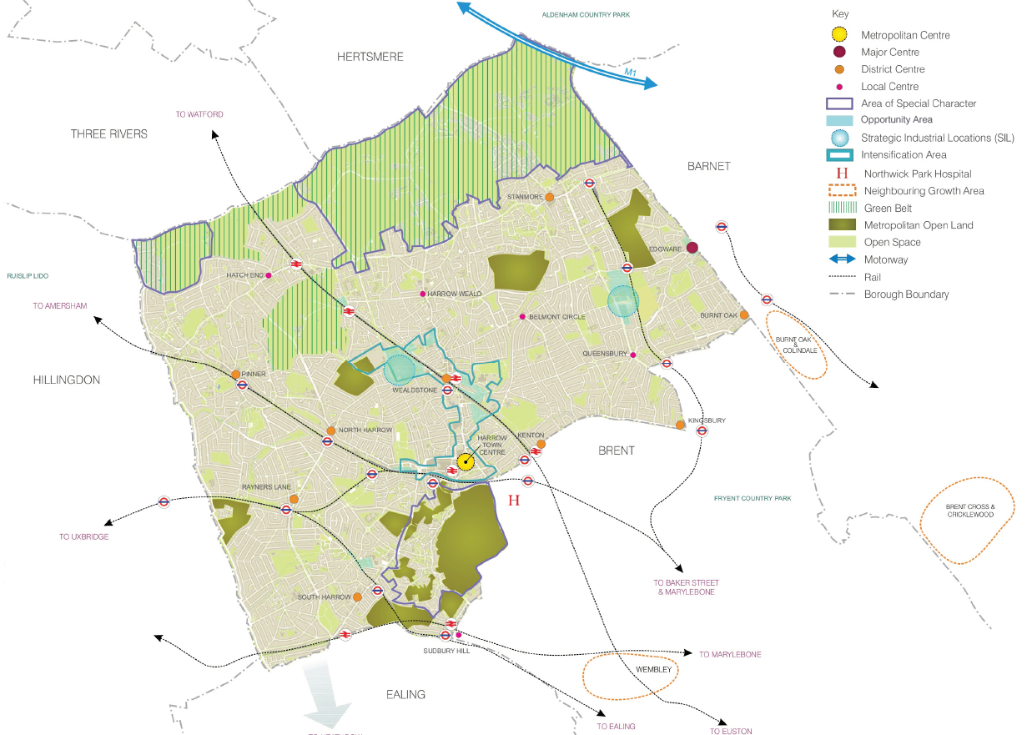

Population
    - London faces significant projected population growth (70,000 every year), reaching 10.5 million in 2041. This means that just to meet demand, at least 66,000 new homes need to be built in London every single year. In Harrow, the borough needs to build 13,920 new homes by 2028/29 to meet the growing demand.

    - In addition to population growth, the demographic of the population is forecast to change, including an increase in ethnic minority groups, one person households, lone parents and multi occupation households.

    - Harrow residents enjoy good life expectancy (82.7 years for men and 86.1 years for women) resulting in a disproportionately high increase in the proportion of older residents and adults living alone. Forecasts show these trends are set to continue with an increasing number of people aged over 85. At the opposite end of the age spectrum, the borough will also see a growth in the under 15 age group (9.8%) reflecting Harrow’s role in providing suburban family accommodation. It is expected that the number of residents aged 65 plus will increase by 42% and those aged 85 plus could increase by 62% by 2029.

    - Harrow is already one of the most diverse boroughs in London and the most religiously diverse in the UK. A significant proportion of Harrow’s residents are of Indian origin and overall around 53% of the population are from minority ethnic groups with this figure being higher in certain parts of the borough (e.g. Kenton East) and in the school age population.

    - There are around 84,300 households in Harrow; the average household size in the borough is estimated to be about 2.8 persons (higher than the London average) while the proportion of one-person households is estimated to be lower than the London average.

Employment
    - There are just over 10,000 businesses in Harrow; 78% of these are small businesses employing less than 4 people and 91% employ 10 people or less. However there are 38 businesses employing 200 people or more and these account for 25% of the borough's employment; Public administration, education and health is strongly represented in Harrow's economy while banking, finance and insurance is under represented.

    - In recent years there has been strong growth in new business formations in the 'legal, accountancy and other business support' and 'construction, personal, community service, retail trade and repairs' sectors.

    - Employment forecasts project a net increase of 4,000 jobs in the borough over the period 2009-2026; growth sectors include hotels and restaurants, business services and other services, however contraction is expected in the manufacturing, construction, wholesale, public administration, health and education sectors.

    - Around 31% of Harrow’s residents work within the borough, 22% commute into central London, and about 25% work in the neighbouring boroughs of Brent, Hillingdon, Barnet and Ealing; there is also significant in-commuting into the borough most notably from south Hertfordshire (Watford, Hertsmere).

Health
    - One in five children in Harrow is overweight at age 5 rising to more than one in three by the time they are 11. Two thirds of Harrow adults are estimated to be overweight. Obesity increases the risk of developing heart disease, stroke, cancer and long term health conditions such as diabetes and hypertension. In 2016/17 there were 19,637 people aged 17 years or older with diabetes. The total prevalence of people in Harrow with diabetes, diagnosed and undiagnosed, is estimated to be 10.5% of the population; this is the second highest local authority prevalence in England. Wealdstone has the highest level of diabetes in the borough.

    - People with diabetes are at a higher risk of having a heart attack or stroke. In Harrow, people with diabetes were 100.5% more likely than people without diabetes to have a heart attack compared to 86.9% nationally. Also, people with diabetes in Harrow were 44.5% more likely to have a stroke, compared to 58.5% nationally. For people with type 2 diabetes, 23.3% are of white ethnicity and 72.0% from a minority ethnic group. Encouraging active travel is one of the key ways of improving the health of those with diabetes and also a way to support effective and sustained weight loss.

    - Harrow is less active and more inactive than London and the nation as a whole:
Nearly one in three (31%) of the adult population in Harrow is classed as physically inactive falling into the Chief Medical Officer’s “high risk” health category. This means that 31% of the adult population in Harrow do less than 30 minutes of moderate intensity physical activity per week. This is higher than for London (27%) and the national (27.7%) level of inactivity.

    - In 2016, a joint approach between Harrow Council and the voluntary sector undertook a large scale project to develop a picture of what local young people in the borough are going through. The project is known as This is Harrow. This work included 51 charities directly involved, heard from 4,358, young people, partnered with 8 schools and directly worked with Harrow Council departments including, Health, Harrow Clinical Commissioning Group (CCG), Harrow Local Safeguarding Children Board (LSCB), and also London Metropolitan Police. Participants represented 15% of the Harrow 10 – 19 year old population. The results of the study were published in 2018. The study showed that only 51% of 18 year olds take 30 minutes of exercise each day compared with 74% of 11 year olds. Figure 1 shows the amount of exercise children of different ages do each day.

Figure 1: Children exercise level in Harrow

    - Only 76.9% of people in Harrow do any walking at least once a week which is below the England average of 80.6%. Harrow has the 2nd lowest levels of walking in London. Premature mortality can be significantly reduced through doing more physical activity. It is estimated that around 14.2% of the new Type 2 diabetes cases in Harrow could be prevented if adults were 100% more active, and 5.6% prevented if adults were 50% more active.

The Environment
    - Over a quarter of the borough consists of designated open space; residential gardens provide private or communally accessible spaces. Harrow’s land area includes 1,088 hectares Green Belt and a further 313 hectares Metropolitan Open Land. Statutorily protected assets include 2 Sites of Special Scientific Interest, 28 Conservation Areas, over 300 listed buildings, four historic parks and gardens, and 9 scheduled ancient monuments. Figure 3 shows the key environmental features in the borough.

    - In 2002, Harrow designated the whole borough an Air Quality Management Area and therefore has an action plan to improve air quality to within National Objective levels. Across London, there has been a gradual reduction in NO₂, PM₁₀ and PM_{2.5} concentrations at background sites in both inner and outer London and at outer London roadside sites. It is estimated that around half of nitrogen oxides (NOx) emissions come from road transport sources. Air quality is expected to improve across Harrow as motor engines become more efficient.

    - Harrow’s carbon footprint is calculated at 11.41 tonnes of Carbon Dioxide (CO₂) per capita, which is higher than the London average but lower than the national average at 11.28 and 12.10 tonnes of CO₂ per capita respectively. The domestic sector (i.e. Housing, and more specifically the electricity, gas and other fuels used in the home) is responsible for the highest portion of emissions, accounting for 53% of the CO₂. In total, Harrow contributes 2.1% of all the CO₂ emitted across London. This puts the borough in 28th position out of the 33 London boroughs.

    - The Green Flag Award scheme recognises and rewards well managed parks and green spaces, setting the benchmark standard for the management of recreational outdoor spaces across the United Kingdom and around the world. Harrow had achieved the ‘Green Flag’ quality status for four of its public parks: Canons Park, Harrow Recreation Ground, Pinner Memorial Park and Roxeth Recreation Ground.

    - Harrow has a composting and recycling rate of 46%, one of the highest in London, and has signed up to the Nottingham Declaration (2007) to reduce carbon dioxide emissions.

    - In 2018, Harrow’s Headstone Manor was one of six projects in London to be awarded funding for green space improvements – as part of the Mayor of London’s push to make London the world’s first National Park City. The additional funding will introduce new and attractive wetlands at the historic grounds, which will also help preserve a 14th century moat. As a result there will be new ponds, improved water quality, better and protected river networks and increased biodiversity.

    - Daily water consumption in Harrow is 170 litres per person per day (higher than the national average of 150 litres).

    - Much of the lighting in Harrow is near its end of life and therefore needs replacing. Replacing existing lighting will ensure structural integrity and provides an opportunity for lighting to be upgraded. Lighting is being improved by a change to LED, to ensure that the levels of lighting wherever needed across the borough are brought up to the necessary standards. This will also drive a reduction in the volume of energy consumed and ensure that the borough can meet the Government’s and the Mayor of London’s green agenda.

    - The borough is located at the upper reaches of the Thames basin, tributaries of the Crane, Colne and Brent Rivers rise in Harrow. Consequently, some parts of the borough are susceptible to fluvial and surface water flooding.

    - The borough is one of the safest in London, consistently in the top five lowest crime rates across the capital. Despite this, fear of crime remains high, and is one of the main concerns for residents.

Existing borough transport
    - Four London Underground lines serve Harrow: the Metropolitan, Bakerloo, Jubilee and Piccadilly lines; in addition the Edgware branch of the Northern line runs close to the eastern borough boundary and the London Overground network provides services in the borough which supplement the Bakerloo line. Mainline rail services connect the borough to London termini at Marylebone and Euston, and to Clapham Junction, Watford Junction, Aylesbury and Birmingham. Figure 4 shows the rail and road transport surrounding the borough.

    - Evidence shows that there is currently adequate carrying capacity on Underground services in the borough; however the provision of step-free access remains an issue at many of the borough’s stations including the busiest, Harrow-on-the-Hill Station.

    - The A40, M40 and M4 motorways are close to the southern boundary while the M1, A1 and A41 are close to the north Furham Field, Hatch End - Pinnerwood Park Estate, Hatch End - Hatch End Station east corner; the M25 provides the major orbital route to the north and west while the A406 North Circular Road is to the south east.

    - Harrow is unique in London having no roads that are part of the Transport for London Road Network. This means that Harrow is responsible for the maintenance, management and operation of all non-motorway roads in the borough.

    - The condition of the road network is an issue of high concern for Harrow residents. It is also a high political concern for Councillors. This is a National issue and not more relevant to Harrow than other areas.

    - There are 37 bus routes, including 5 night bus services, serving areas within the borough and links to neighbouring boroughs; however Harrow bus station is operating over capacity.

    - A network of cycle routes provides a total of 41km cycle lanes in the borough. This is around 10% of the Harrow road network. Figure 5 shows the existing cycle routes through the borough.

    - According to the 2011 census, around 76% of households in Harrow owned a car and nearly a third of households recorded that they had access to two or more cars at home. This is higher than car ownership nationally which is around 74%.

    - Public Transport Accessibility Level (PTAL) is a way of measuring connectivity to public transport. The PTAL value combines information about how close public transport services are to a site and how frequent these services are. The highest level of connectivity has a PTAL of 6b and the lowest has a PTAL of 0. Figure 6 shows PTAL information across the borough. Figure 6 shows PTAL levels across the borough.

Figure 2: Harrow in London
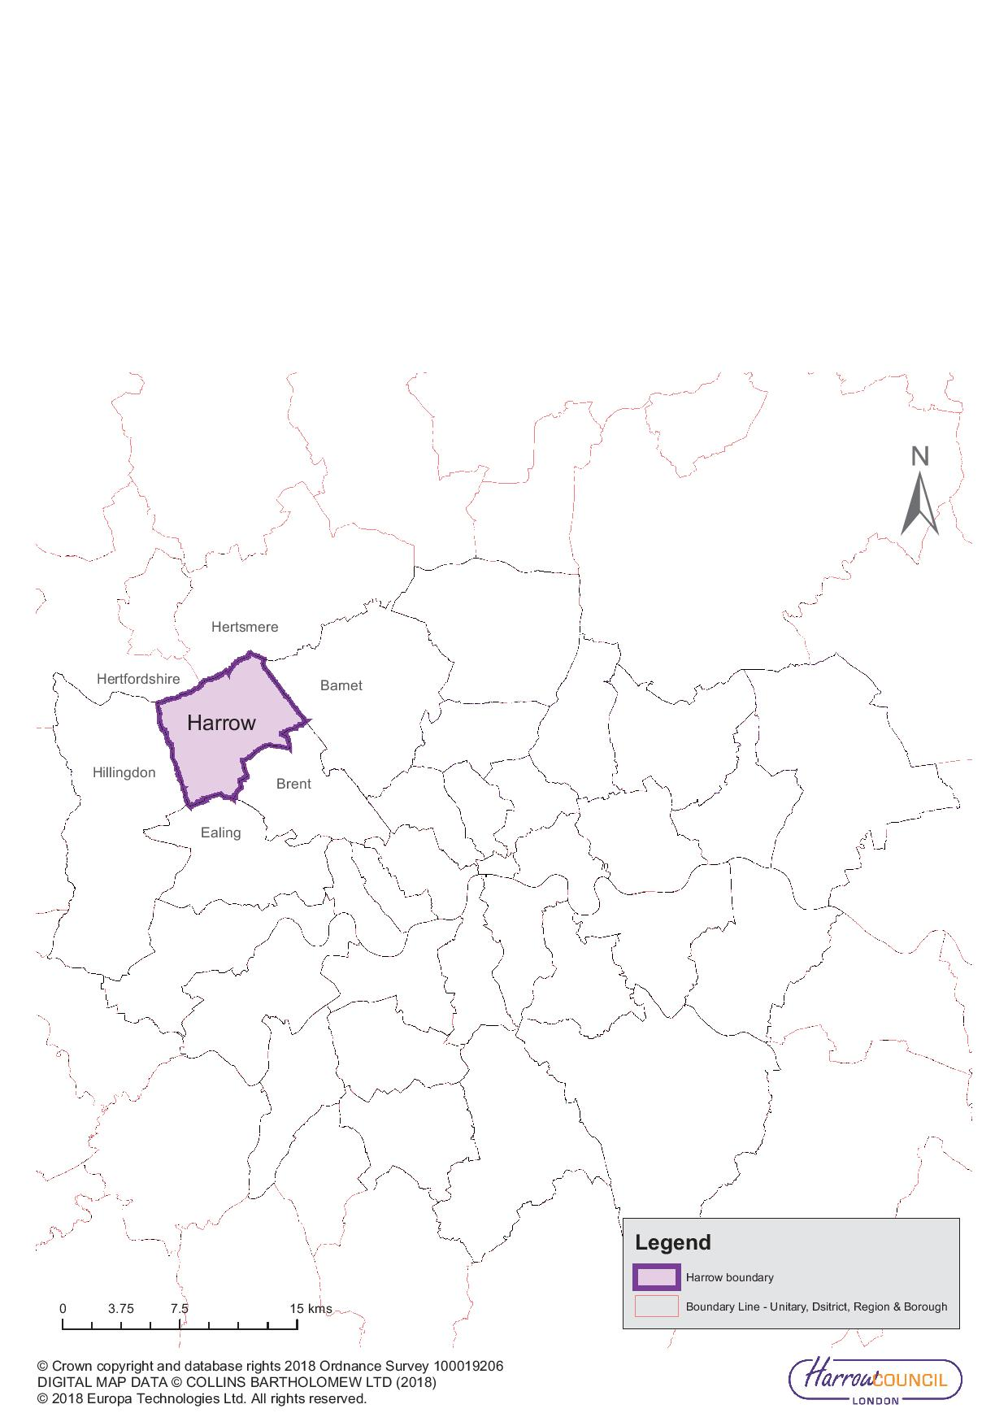

Figure 3: Harrow key environmental features
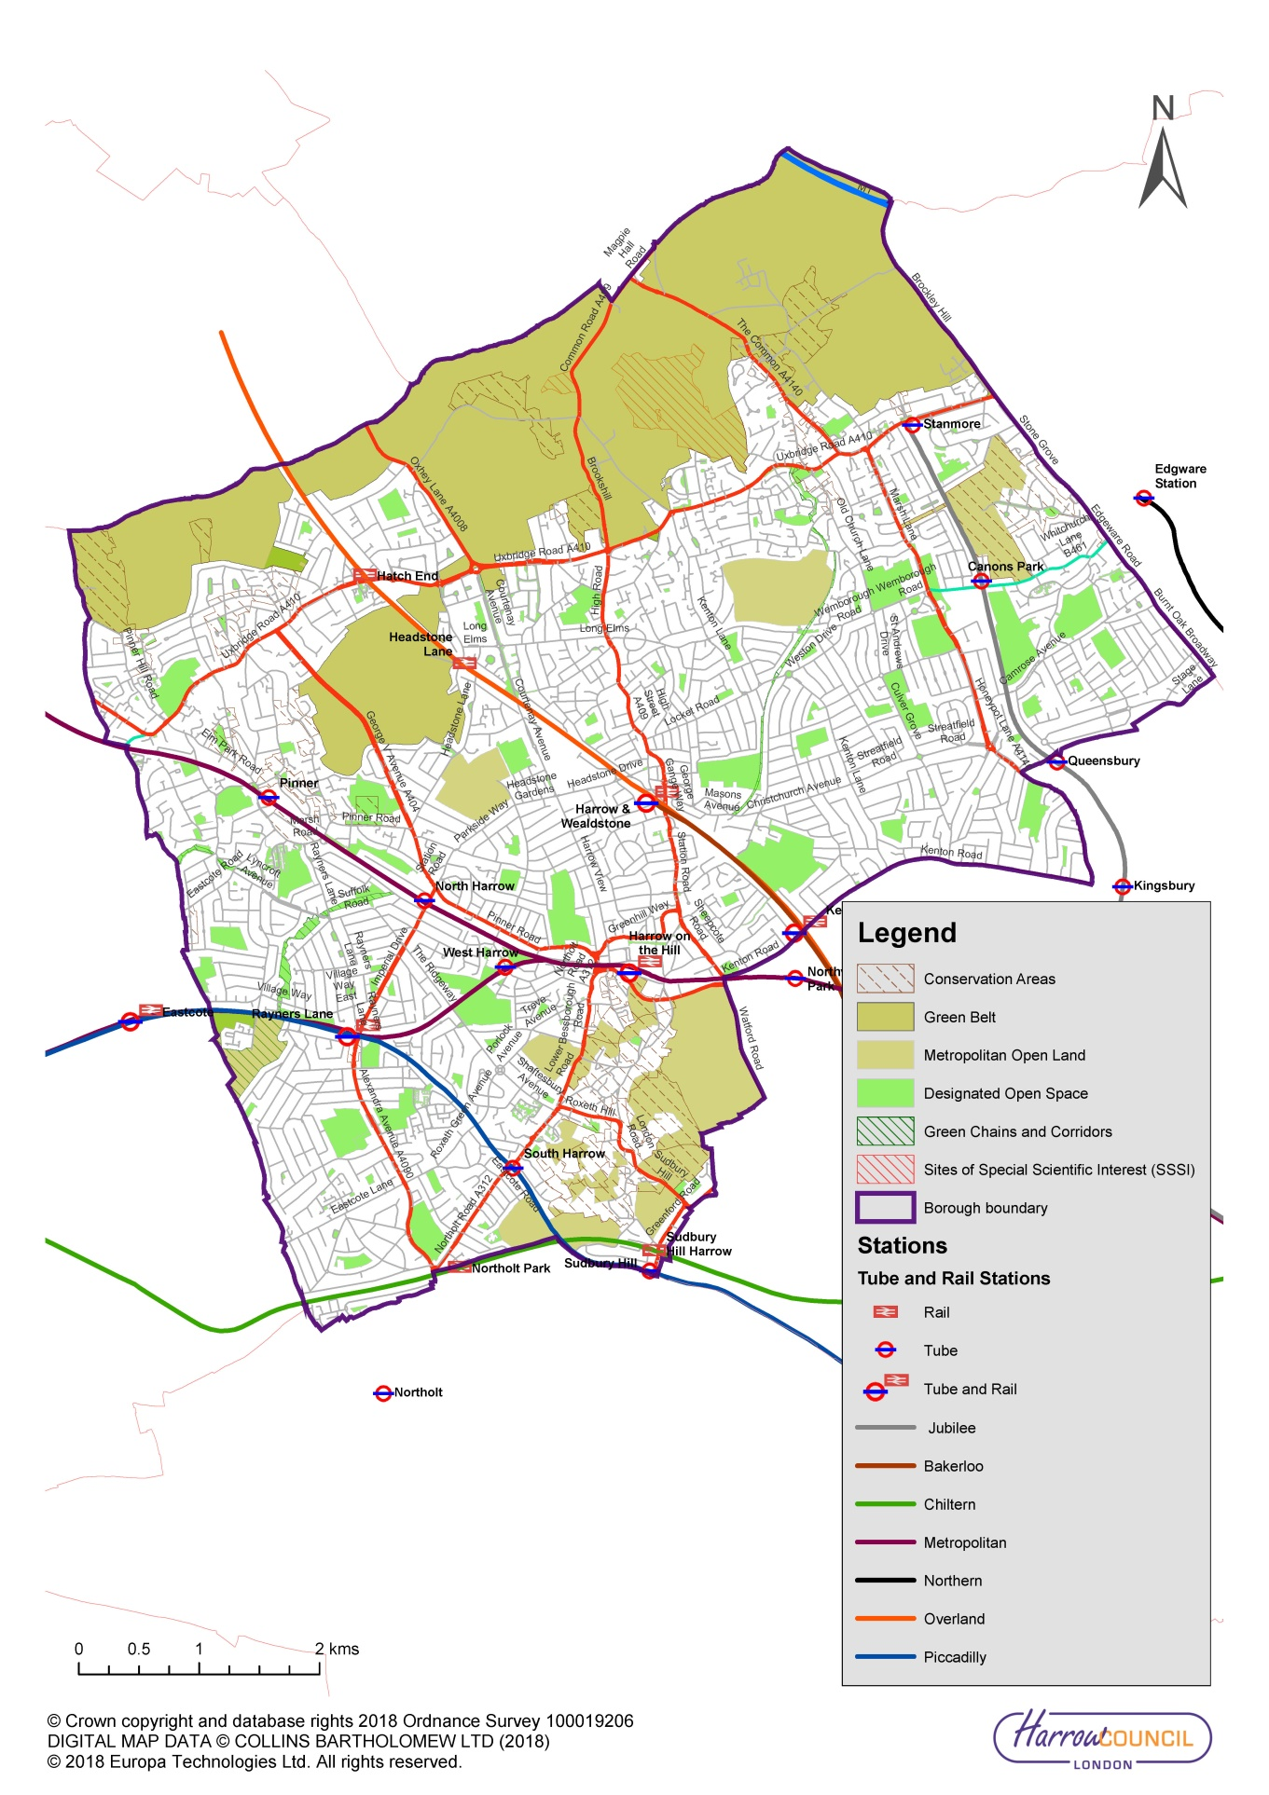
Figure 4: Road and rail lines surrounding the borough
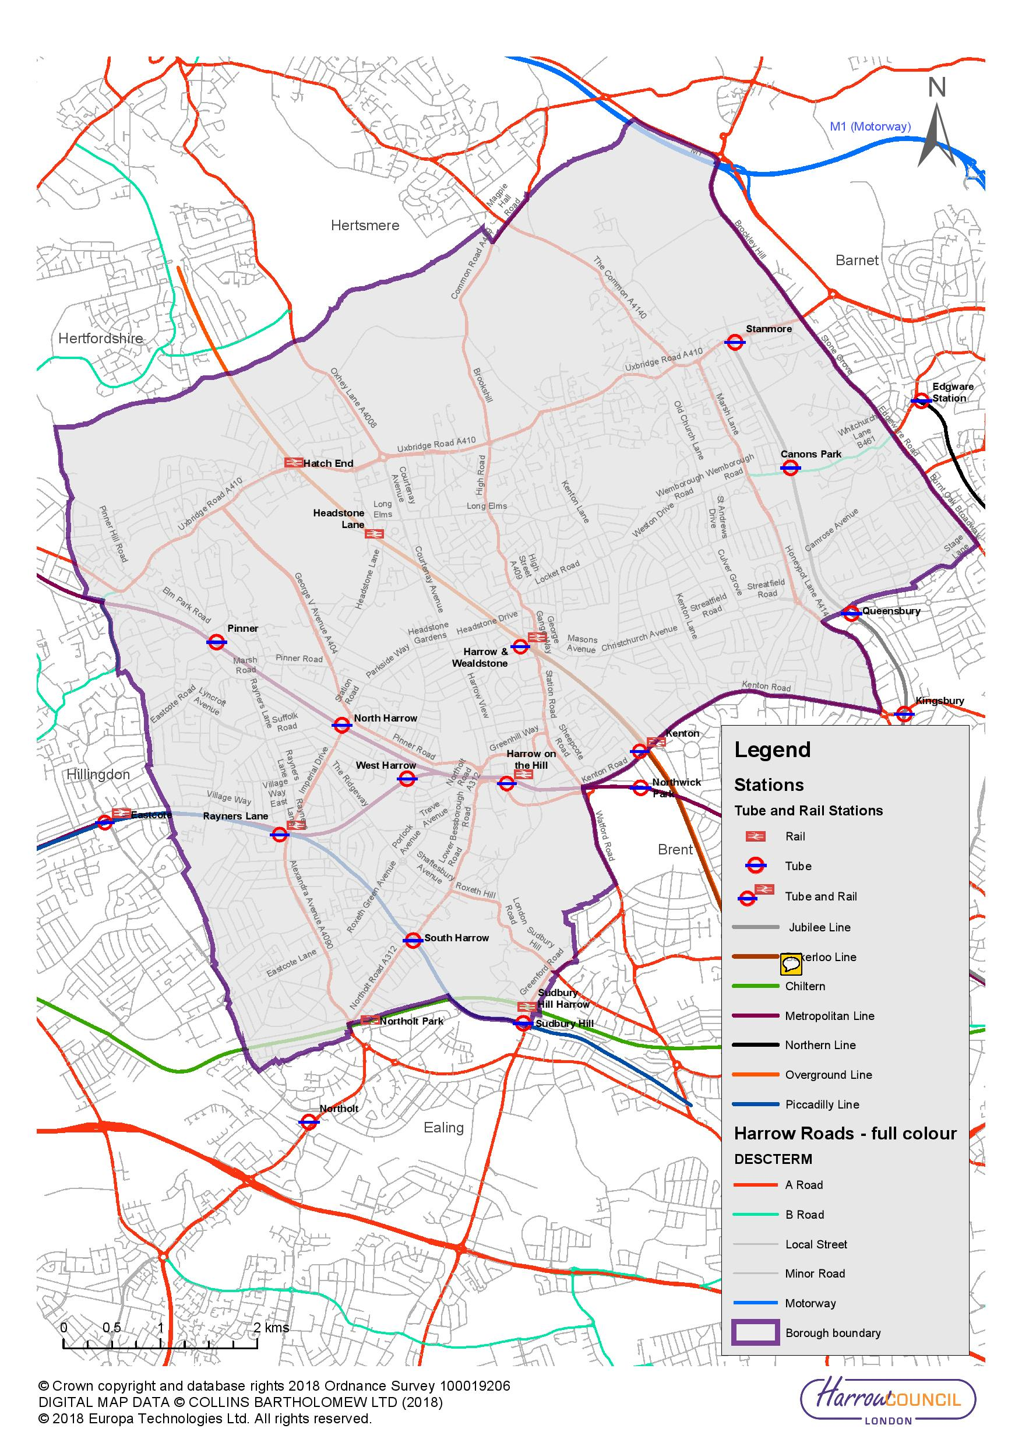

Figure 5: Cycle routes in Harrow
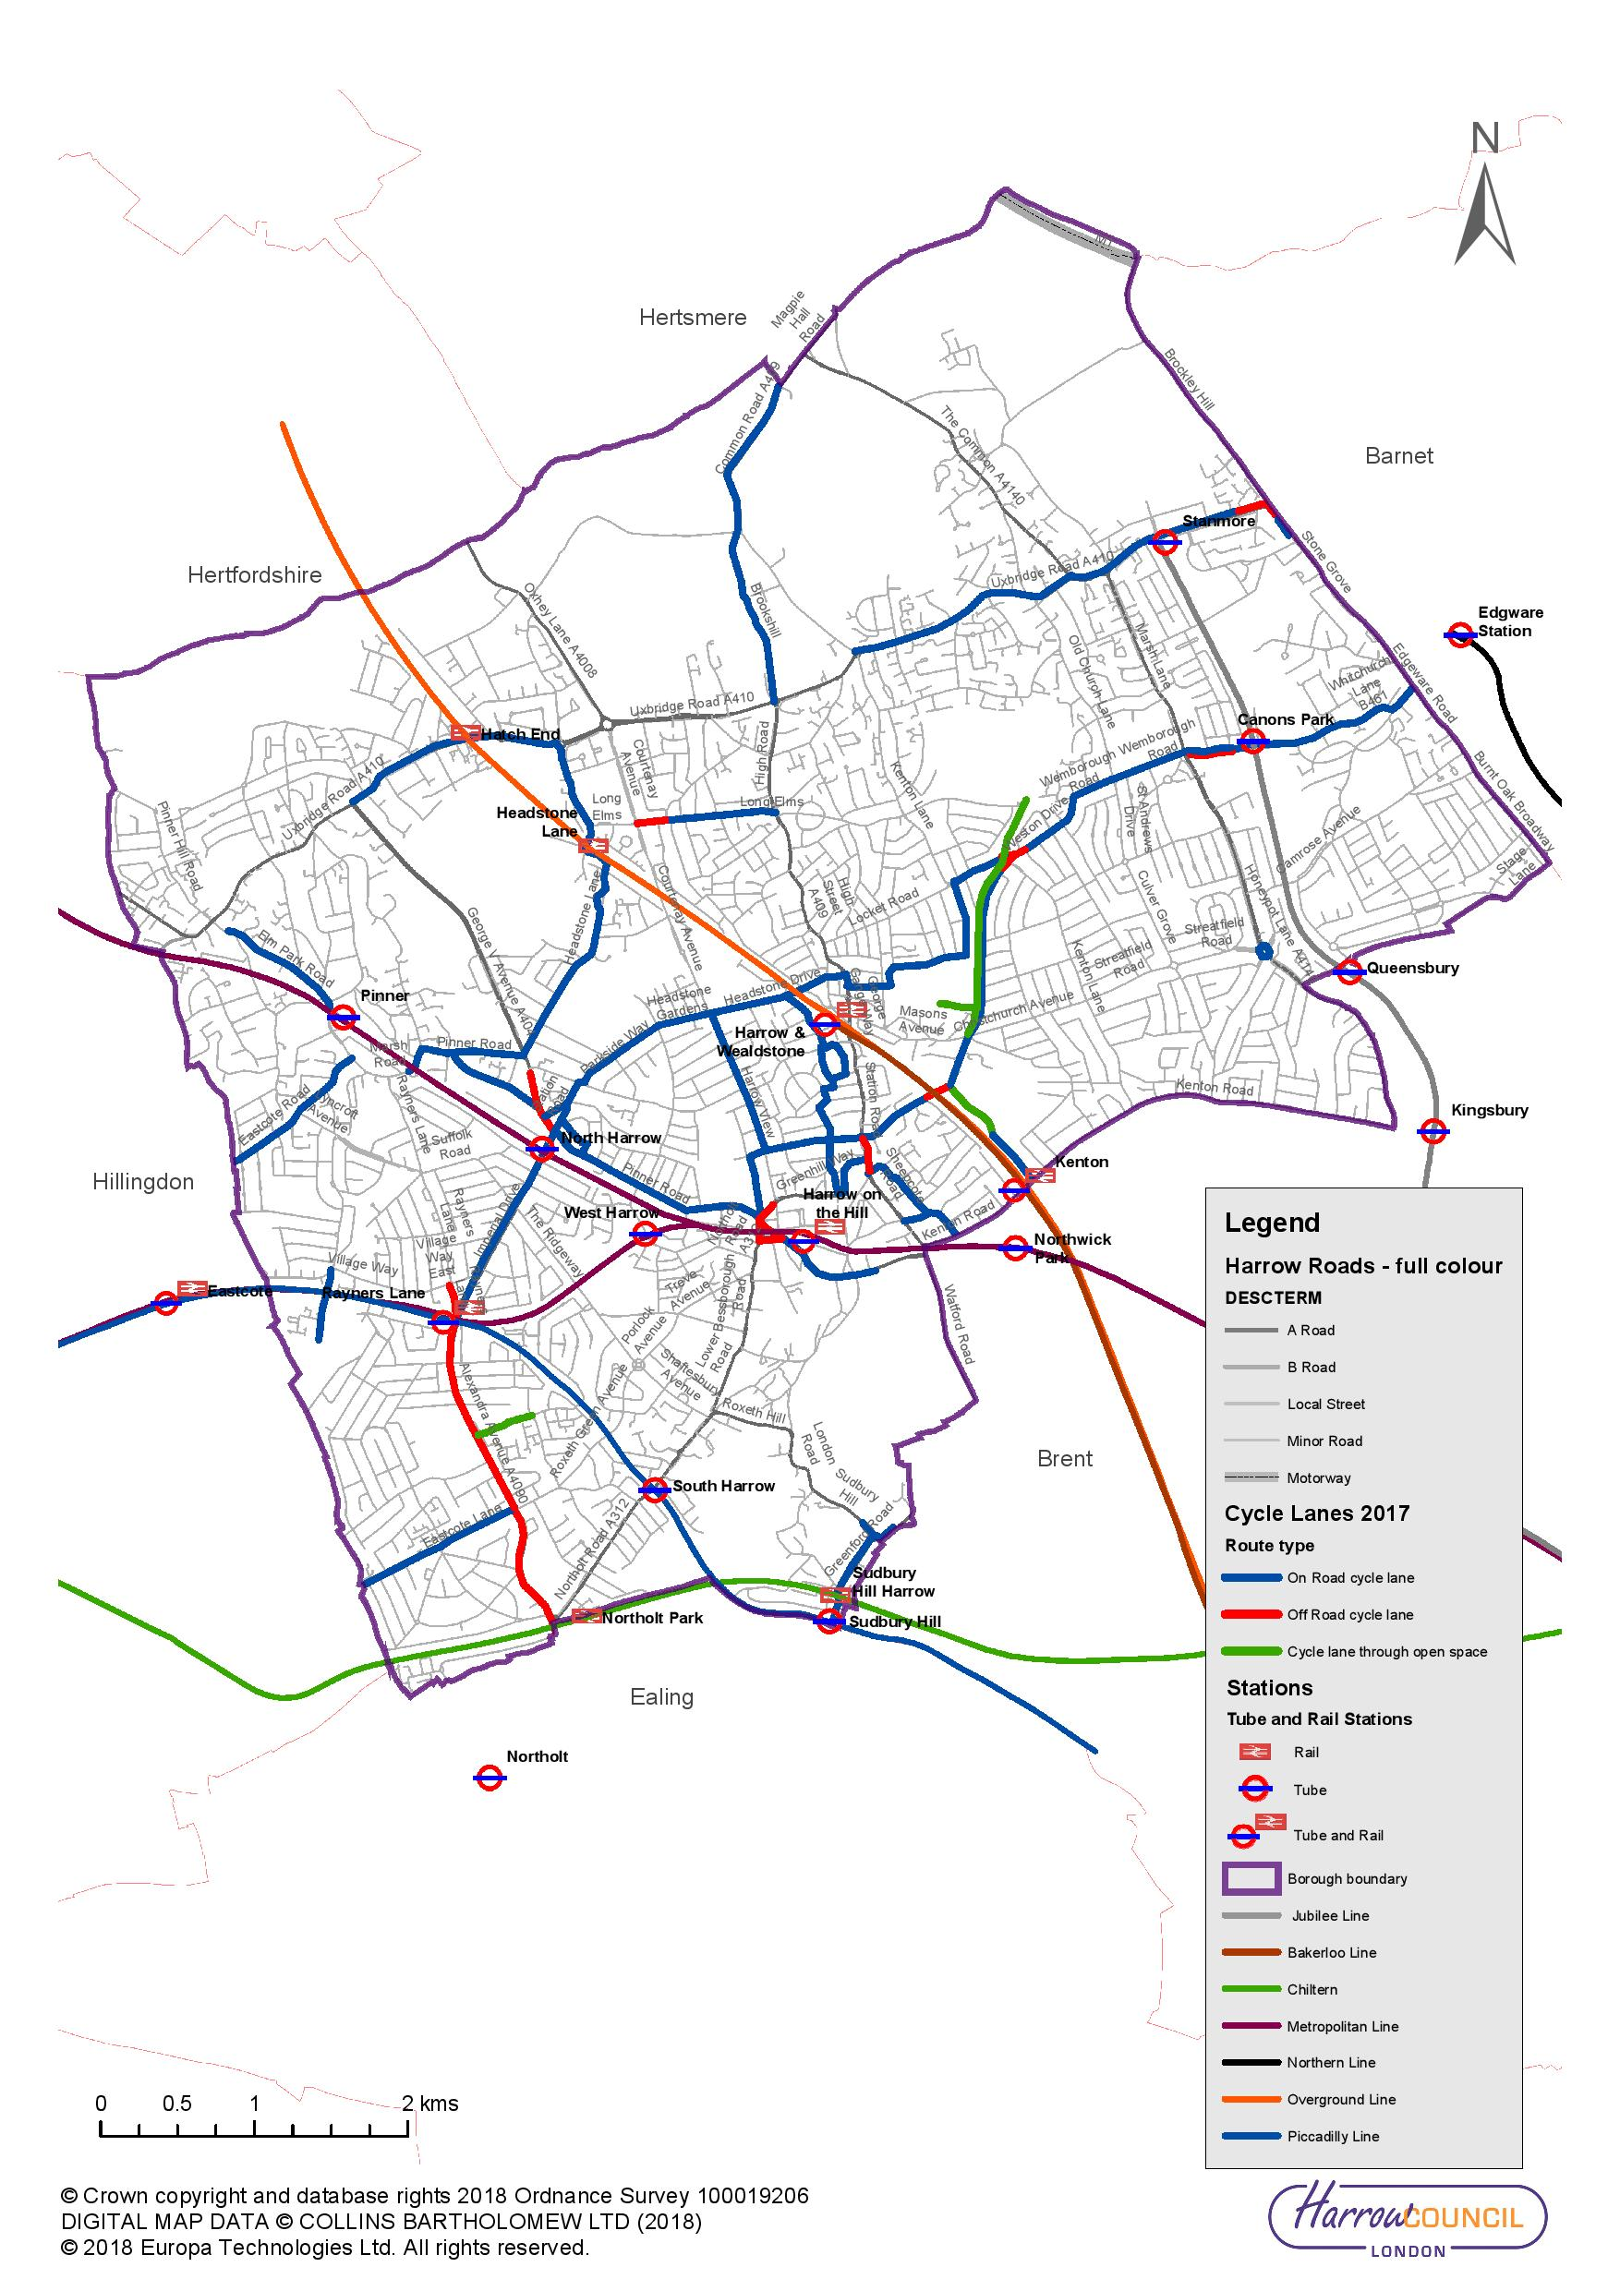

Figure 6: PTAL across Harrow
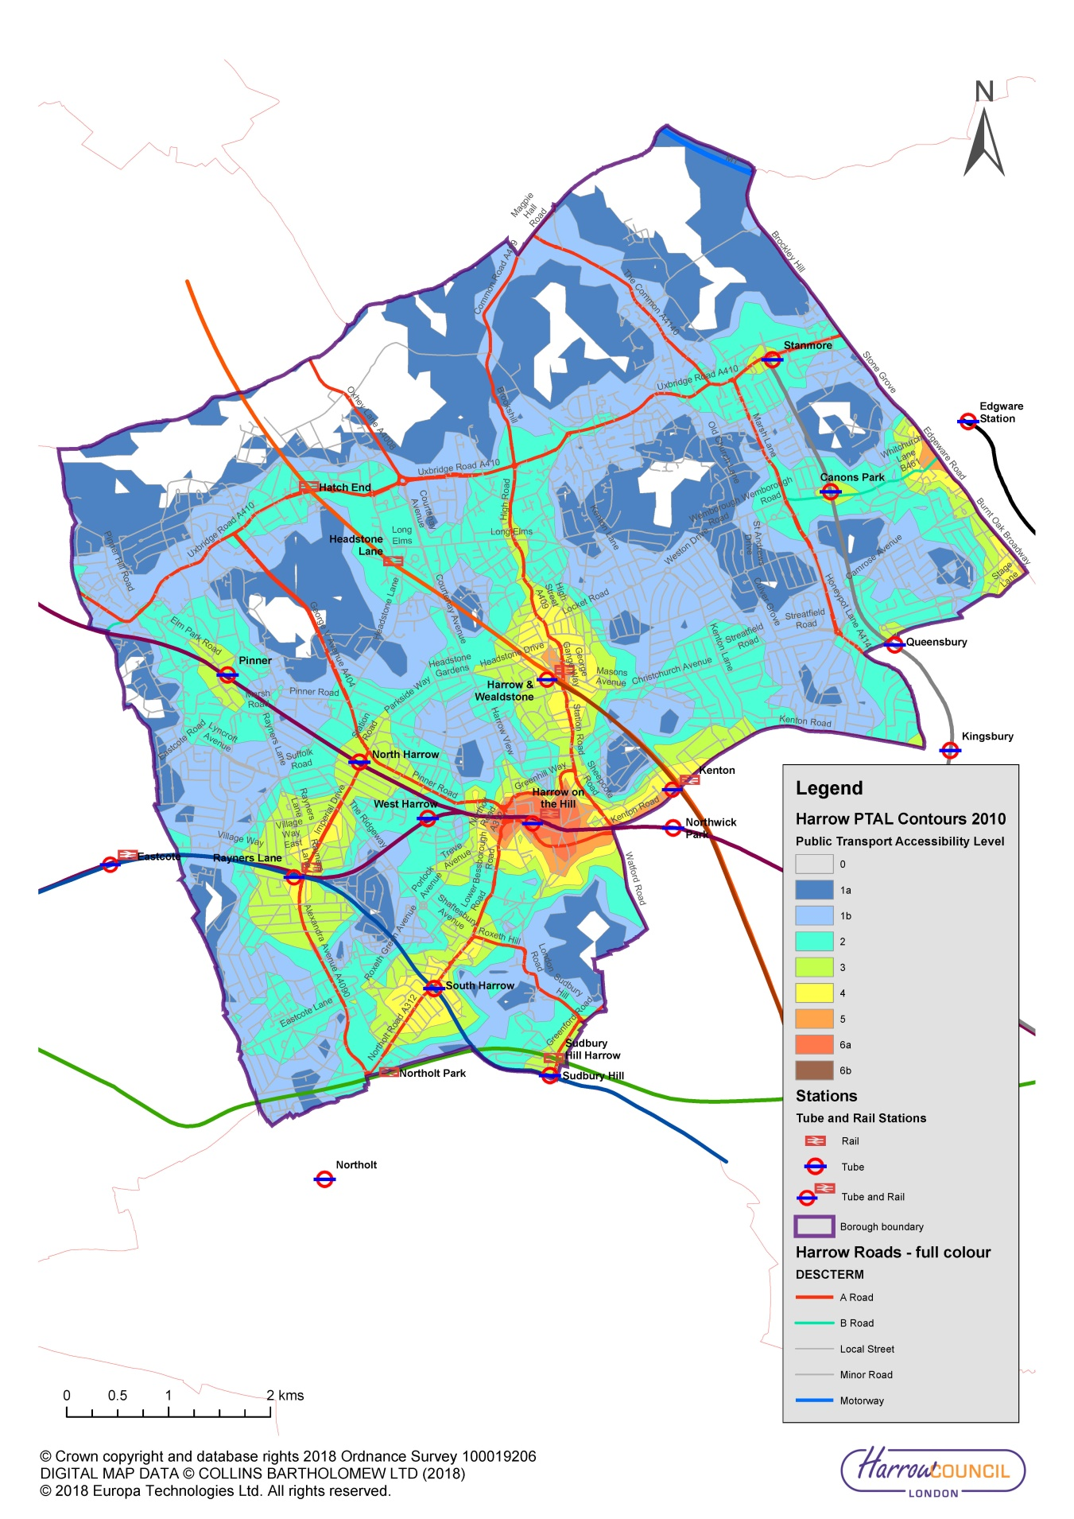

Changing the transport mix

Challenges and opportunities
    - Harrow is committed to changing the transport mix in the borough and increasing the amount of active travel. The current level of cycling in the borough is disappointingly low despite ongoing efforts to increase cycling opportunities. Harrow was ranked the lowest of the 33 London boroughs for residents who cycle to work in the 2011 census.

    - Changing the transport mix in the borough is being addressed through a combination of tools. These include the borough’s development and planning processes, ensuring appropriate parking restrictions are used where needed, effective travel planning, public realm improvements, active travel promoted through Harrow’s health agenda and by working with schools to increase cycle training and through improved engineering designs.

    - Improved engineering designs will deliver liveable neighbourhoods, increased neighbourhoods of the future, provide better infrastructure support for electric vehicles, more facilities for cycling (including e bikes) and an improved walking environment. To improve the environment for walking and cycling, the overall perceptions of safety in the borough also need to be considered. This will be addressed by extending 20mph zones, delivering healthy streets and delivering appropriate road safety engineering measures at specific locations. None of these measures alone will make a sufficient impact. All of these changes together can do so.

    - Active travel is also an important way that Harrow encourages more walking and cycling. Harrow is committed to increasing physical activity among residents particularly for those people who are inactive as shown in Active Harrow Physical Activity and Sports Strategy 2016-20. Harrow takes a life–course approach and advocates taking actions which will benefit everyone but with a greater emphasis and intensity on those who are more disadvantaged. The guiding principles for the Harrow Health and Wellbeing Strategy 2016-20 are: Start well, Develop well, Live well, Work well, Age well and work on social determinants to address the health divide between the rich and the poor. It is recognised that without a focus on being more active, obesity and diabetes rates may continue to rise.

    - In recent years, growth and development in Harrow took place on a largely ad hoc basis. However the Harrow Core Strategy (2012) and Regeneration Strategy (2015) have moved the Council from being one that is reactive to one that promotes, manages and co-ordinates development. This approach will ensure the social, economic and place-making benefits of new development and growth can be realised. Better planning can reduce the need to travel by car.

    - The Harrow Opportunity Area is the focus for growth in the borough. The designation is recognised in the London Plan as being a location that can accommodate change and has capacity to do so. In district and local centres, positive policy interventions will be used to reduce vacancy rates, deliver improvements to the public realm and, where appropriate, reinforce and enhance the historic and distinctive features that contribute to a centre’s character and appeal. The focus on the Opportunity Area and the forecast growth provides an opportunity to delivery an area where the change in the transport mix will be both significant and visible.

    - Wealdstone and Station Road which are in the Opportunity Area is the focus of the borough regeneration efforts, providing for a substantial proportion of the borough’s future housing growth. Urban realm enhancements and the provision of mixed use development will drive a new urban form and the intensification of employment generating uses of industrial sites.

    - It will not be enough simply to deliver engineering solutions to the borough and hope that they have the desired behavioural effect. Changing behaviour will also require the new infrastructure to be joined up in a way that the borough effectively works. The importance of changes being made needs to be promoted. Streets need to be inviting places for all, so that residents, visitors, employers and employees can better appreciate them.

    - The Community Infrastructure Levy (CIL) and Section 106 funding are particularly difficult to realise in Outer London. The removal of TfL funding to support Harrow’s principal road maintenance has also added to the challenge of delivering some of the necessary improvements.

    - Delivering the changes in a time of austerity will be a significant challenge. However delivering the change is also an important part of the borough’s commitment to tackling the urgent environmental issues the borough faces as well as addressing the significant risks of longer term climate change.

    - Harrow’s Local Development Framework, the borough’s Core Strategy, Regeneration Strategy and the policies outlined in this Transport Local Implementation Plan will together enable the borough to deliver the necessary changes and to deliver a significant change in the borough’s transport mix.

Borough objectives
    - Harrow has developed draft LIP3 objectives which cover the period 2019/20 to 2021/22 and also reflect the timeframe of the mayor’s Transport Strategy up to 2041. The objectives have been developed in order to do the following:
- Assist in delivering the borough corporate priorities
- Address Harrow’s key transport concerns
- Help to address local environmental issues relevant to LIP3
- Assist in delivering the Mayor of London’s nine strategic outcomes identified in the MTS
- Assist in delivering the Mayoral aim for 80% of all trips in London to be made on foot, by cycle or using public transport by 2041

    - Harrow’s corporate priorities are:
- Build a Better Harrow
- Be more business-like and business friendly
- Protect the most vulnerable and support families

    - Harrow’s key transport concerns are:
- Reduce motorcycle casualties across the borough
- Increase cycling
- Prioritise the transport needs of the Harrow and Wealdstone Opportunity Area
- The condition of the principal road network which continues to be a very high issue for Harrow residents

    - Harrow’s local environmental issues of particular relevance to LIP3 include the necessity to do the following:
- Reduce traffic as it is the main source of air pollution
- Encourage sustainable travel
- Reduce reliance on the car
- Reduce the volume of car travel
- Reduce river flooding following high rainfalls
- Reduce carbon dioxide emissions to mitigate climate change
- Increase flood resilience
- Enhance biodiversity, fauna and flora
- Deliver health improvements including reducing high levels of obesity and diabetes through active travel

    - Harrow’s draft transport objectives are as follows:

- Improve the public realm through the introduction of healthy streets and liveable neighbourhoods to encourage active and safer travel particularly for pedestrians and cyclists thereby reducing congestion and improving public health and local air quality
- Adopt a Vision Zero approach towards eliminating all road traffic deaths and serious injuries by 2041 and focus on reducing the number of motorcycle casualties across the borough
- Increase the number of people cycling in the borough in order to improve public health, improve air quality, reduce congestion and to reduce the impact of climate change
- Improve freight servicing and delivery arrangements to reduce congestion and delays on the network
- Encourage the uptake of more sustainable modes of travel through active travel initiatives, delivering additional healthy routes to school, promotion of cycle hire schemes, the use of parking and permit policies and prioritising road space to walking and cycling to improve the environment.
- Encourage the uptake of ultra-low emission vehicles instead of fossil fuel powered vehicles through the use of promotional activities, increased Ultra Low emission zones, neighbourhoods of the future, and greater availability of electric charging facilities, thereby improving air quality, reducing traffic noise and reducing CO₂ emissions throughout the borough
- Support improved orbital transport links across the borough and between outer London centres to provide wider access to employment opportunities and to enable journeys currently made by car to be made by sustainable forms of transport and thereby improve the environment
- Improve transport connectivity throughout the Harrow and Wealdstone Opportunity Area and particularly between Harrow-on-the-Hill station/ Harrow bus station and Harrow & Wealdstone station
- Ensure that the vitality of all town centres are supported through good transport links prioritising sustainable modes of transport
- Improve public transport accessibility, support the expansion of bus and rail services throughout Harrow and in particular, support increased bus priority to deliver a more reliable, faster and more accessible public transport experience
- Prioritise sustainable travel improvements for all new developments to support population growth and housing needs identified in the London Plan and local development framework
- Prioritise the transport needs of the Harrow and Wealdstone Opportunity Area
- Keep the transport network in good condition and serviceable to encourage the use of sustainable transport modes

    - The borough intends to deliver significant progress in the delivery of the following objectives over the shorter term.
- Improve the public realm through the introduction of healthy streets and liveable neighbourhoods to encourage active and safer travel particularly for pedestrians and cyclists thereby reducing congestion and improving public health and local air quality
- Increase the number of people cycling in the borough in order to improve public health, improve air quality, reduce congestion and to reduce the impact of climate change
- Encourage the uptake of more sustainable modes of travel through active travel initiatives, delivering additional healthy routes to school, promotion of cycle hire schemes, the use of parking and permit policies and prioritising road space to walking and cycling to improve the environment.
- Improve public transport accessibility, support the expansion of bus and rail services throughout Harrow and in particular, support increased bus priority to deliver a more reliable, faster and more accessible public transport experience

    - The link between Harrow’s objectives and the Mayor’s desired outcomes are shown in Table 2.
Table 2: Link between Harrow objectives and Mayoral outcomes
 | - London’s streets will be healthy and more Londoners will travel actively | - London’s streets will be safe and secure | - London’s streets will be used more efficiently and have less traffic on them | - London’s streets will be clean and green | - The public transport network will meet the needs of a growing London | - Public transport will be safe, affordable and accessible to all | - Journeys by public transport will be pleasant, fast and reliable | - Active, efficient and sustainable travel will be the best option in new development | - Transport investment will unlock the delivery of new homes and jobs’
- Improve the public realm through the introduction of healthy streets and liveable neighbourhoods to encourage active and safer travel particularly for pedestrians and cyclists thereby reducing congestion and improving public health and local air quality
- Adopt a Vision Zero approach towards eliminating all road traffic deaths and serious injuries by 2041 and focus on reducing the number of motorcycle casualties across the borough
- Increase the number of people cycling in the borough in order to improve public health, improve air quality, reduce congestion and to reduce the impact of climate change
- Improve freight servicing and delivery arrangements to reduce congestion and delays on the network
- Encourage the uptake of more sustainable modes of travel through active travel initiatives, delivering additional healthy routes to school, promotion of cycle hire schemes, the use of parking and permit policies and prioritising road space to walking and cycling to improve the environment.
- Encourage the uptake of ultra-low emission vehicles instead of fossil fuel powered vehicles through the use of promotional activities, increased Ultra Low emission zones, neighbourhoods of the future, and greater availability of electric charging facilities, thereby improving air quality, reducing traffic noise and reducing CO₂ emissions throughout the borough
- Support improved orbital transport links across the borough and between outer London centres to provide wider access to employment opportunities and to enable journeys currently made by car to be made by sustainable forms of transport and thereby improve the environment
- Improve transport connectivity throughout the Harrow and Wealdstone Opportunity Area and particularly between Harrow-on-the-Hill station/ Harrow bus station and Harrow & Wealdstone station
- Ensure that the vitality of all town centres are supported through good transport links prioritising sustainable modes of transport
- Improve public transport accessibility, support the expansion of bus and rail services throughout Harrow and in particular, support increased bus priority to deliver a more reliable, faster and more accessible public transport experience
- Prioritise sustainable travel improvements for all new developments to support population growth and housing needs identified in the London Plan and local development framework
- Prioritise the transport needs of the Harrow and Wealdstone Opportunity Area
- Keep the transport network in good condition and serviceable to encourage the use of sustainable transport modes

Mayor’s Transport Strategy outcomes

    - This chapter shows how Harrow will work to deliver each of the Mayoral outcomes. A full summary of all of the Harrow policies provided in this chapter is provided in Appendix A.

Outcome 1: London’s streets will be healthy and more Londoners will travel actively

Challenges and opportunities
    - The borough has very high car ownership compared with much of London, with nearly a third of Harrow’s households having access to two or more cars. However there remain around 25% of households with no car access at all. These households are mainly in the central part of Harrow, Greenhill, Marlborough and Wealdstone areas. These are the areas with highest PTAL and connectivity to central London which reduces the need for a car and demonstrates the benefits of improving PTAL elsewhere across the borough.

    - For many of those living in the borough, the ease of taking the car is simply too appealing. To encourage those with access to a car to walk, cycle or use public transport, the alternatives need to compete favourably against the car in terms of journey times and reliability, comfort and personal independence. Active travel is far cheaper and in many cases quicker than other transport modes, but people are not always aware of this.

    - To encourage active travel and deliver a modal shift towards more sustainable forms of transport, the borough needs to improve the environment for pedestrians and cyclists in the whole borough and particularly within new growth areas such as the Harrow Intensification Area. To do this across the borough, Harrow will deliver more healthy streets and ‘Liveable Neighbourhoods’ to improve people’s experience of walking, cycling and using public transport and to encourage fewer trips by car. As ‘Liveable Neighbourhoods’ and healthy streets are introduced, increased planting and street greening will be introduced and issues of severance caused by high traffic flow will be addressed.

    - The Healthy Streets approach is the framework for the Mayor’s Transport Strategy. Figure 7 shows the ten indicators that are used to measure Healthy Streets. Using these evidence based indicators will help to ensure that streets are made to be more attractive places. This will enable Harrow to work towards creating a healthier street environment increasing the number of people walking, cycling and using public transport and improve streets so that all people are included and can live well, and where inequalities are reduced.
Figure 7: Healthy Streets indicators
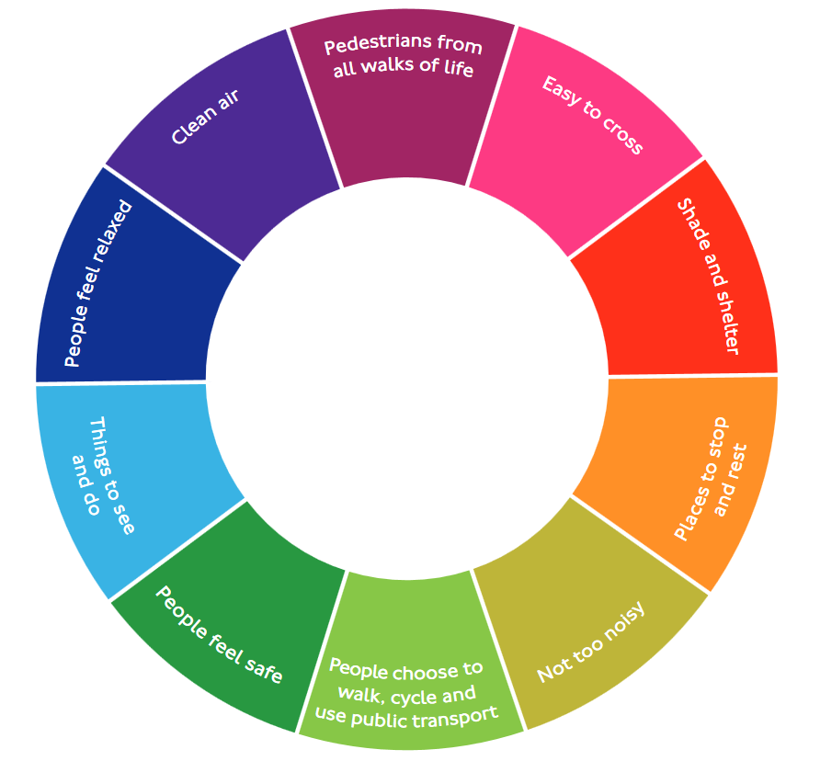

    - Harrow Council offices are moving. The new site will be ready by 2021 and a new travel plan for the site has been agreed. There will be a significant reduction in parking spaces on the new site and significant modal shift will be required and delivered to adjust to the new premises.

    - Encouraging active travel for children and those without access to a car is far easier. Awareness of both the physical and psychological health benefits of cycling and waking and the importance of protecting the environment are all issues that encourage increased use of sustainable modes. The borough has high levels of diabetes and health improvements are being addressed through encouraging increased walking and cycling and promoting the enjoyment of Harrow’s greener spaces.

    - Fast traffic is a deterrent to walking and cycling particularly for children and vulnerable road users. The majority of pedestrian casualties occur in built up areas.
The main aims of the introduction of a 20mph speed limit in an area are to:
- improve road safety
- discourage passing through traffic
- encourage walking and cycling
- improve the local environment

    - Figure 8 shows all the 20mph zones in the borough. Zones are designed to be "self-enforcing" due to traffic calming measures which are introduced along with the change in the speed limit. Speed humps, chicanes, road narrowing, and other measures are typically used to both physically and visually reinforce the slower speed limits.

Figure 8: 20mph zones within Harrow
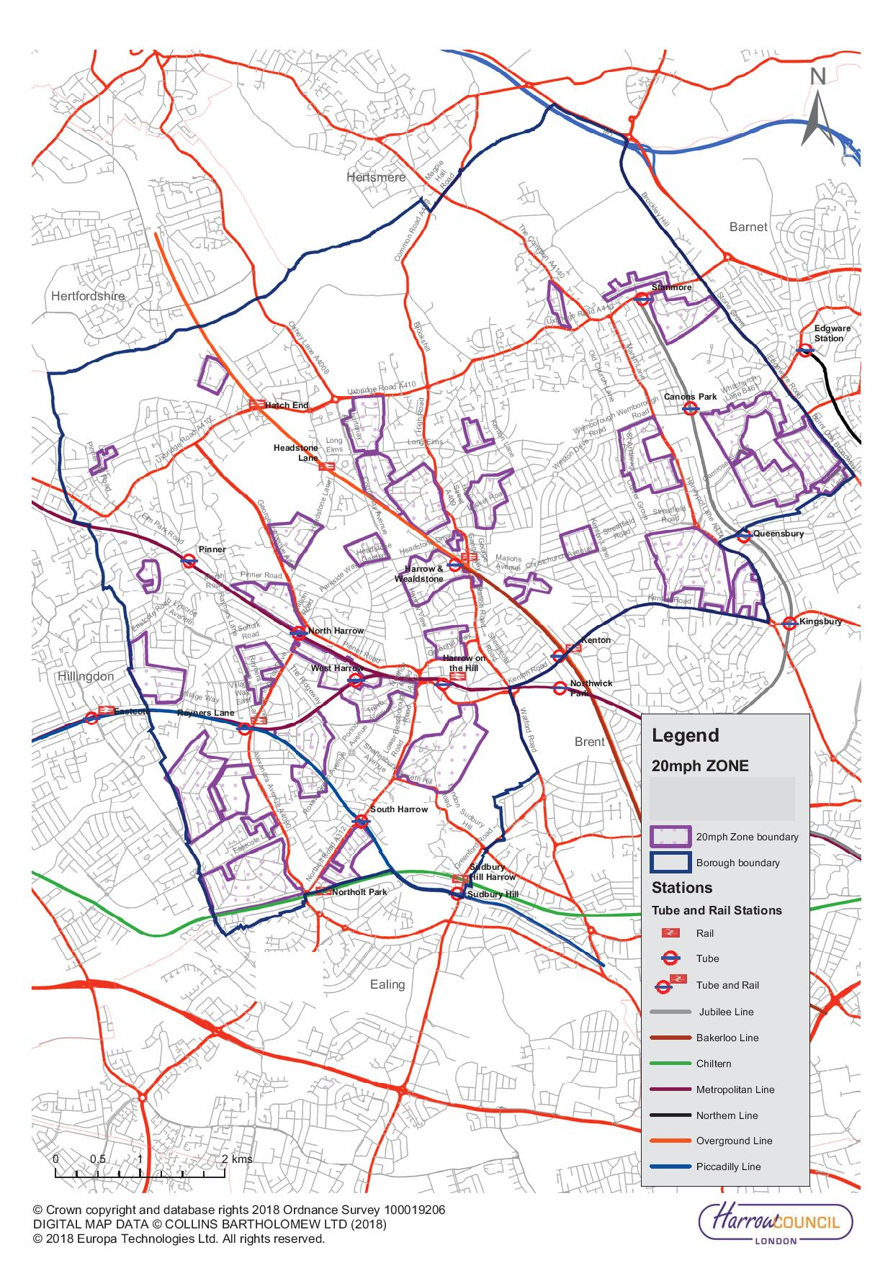

    - Harrow has been identified as one where there is scope to increase cycling and it has been estimated that there are a potential of 228,100 cyclable trips in the borough. This is being actively pursued through more travel planning, increased cycle training and better facilities for cyclists. TfL’s Analysis of Cycling Potential published in March 2017 identified a potential to increase cycling throughout London. Harrow has also considered the Strategic Cycling Analysis (SCA) identifying future cycling demand in London published by TfL in June 2017. This shows that much of the top potential cycle demand is on London’s strategic road network. The SCA also shows that Pinner, Rayners Lane, Harrow Town Centre and Edgware carry the highest number of potentially cyclable trips in the borough, and that there is a greater propensity to cycle from these locations. Cycling Transport Accessibility Levels (CTALs) calculated in the SCA show the current potential for cycling accessibility. Harrow will consider the local CTAL scores in identifying new cycling infrastructure and additional cycle parking upgrades.

    - To encourage increased cycling, cycle training is offered to all schools in the borough as well as offered outside the school environment. Cycle training is also facilitated for Special Educational Needs and Disability (SEND) schools providing an extended duration of training and adapted bikes for pupils to participate in training. The borough also offers women only cycle training courses. To ensure that those who need to benefit from the health of increased cycling, promotional leaflets are provided across Harrow in doctor’s surgeries and libraries, leisure centres, community notice boards, social media accounts/council website, Harrow People Magazine and Annual Council Tax guide promoting the health benefits of cycling and also providing information on how to access cycle training.

    - Harrow is proposing to construct a brand new BMX cycling facility to transform the lives of young people from disadvantaged communities and encourage the social and health benefits of cycling. The facility will serve the whole community and aims to increase cycling participation with young people from lower social grades and from BAME backgrounds to promote cycling in an exciting and engaging way. The facility will be based within one of the more deprived wards in the borough.

    - In schools across Harrow, the borough also offers Learn to Balance and ride cycle training for those aged 3-11. During these sessions, free bicycles are provided to children to help them to learn the core fundamentals of cycling.

    - Tour de Salah is the largest Muslim cycling event in the UK and introduces cycling to novices within traditionally harder to reach groups. Participating cyclists cover up to 100km across the capitals iconic landmarks and mosques over one day. This year the Harrow Mosque is part of the route and the event is being promoted across the borough.

    - Harrow promotes travel training to eligible children and young adults at all schools in the borough. This provides support for those with learning difficulties to develop the skills and confidence to travel independently. By promoting independence from an early age and reducing people’s dependence on specialist transport, participants can develop independence through accessing learning and employment opportunities and maintain an improved quality of living.

    - To encourage staff cycling, together with WestTrans, Harrow, took part in an e-bike trial. This involved six e-bikes being loaned to staff for a month at a time, to allow them to develop the habit of cycling to work and encourage them to purchase an e-bike for themselves. 36 staff and teams participated in trialling the bikes during the trial.

    - The borough supports the Mayoral aim that, by 2041, all Londoners do at least the 20 minutes of active travel that they need to stay healthy each day. Traffic and Highways are part of the Active Harrow Strategic Group. Active travel initiatives are promoted with this group and with the other council and community and voluntary sector partners. The strategic group is also developing a multi agency focus on two geographical areas of higher obesity and physical inactivity in the borough; an action plan will be developed to promote community led opportunities to be more active in South Harrow and a Superzone pilot based in Wealdstone which will look at a whole system approach to improving the health of the urban environment.

    - To support increased active travel, Harrow provides free Health Walks for local residents with an opportunity to walk regularly in a relaxed and friendly environment and enjoy some of Harrow’s beautiful green spaces. The walks are varied in length and level and are all led by qualified and insured volunteer walk leaders, who encourage participants to walk at their own pace.

    - Harrow promotes the London AirTEXT service on the Council website. This gives advance warning of elevated pollution levels. Harrow has also committed to monitoring air quality sites near schools with a main road within a 5 minute walk of the school. Diffusion tubes put in place at the schools will measure nitrogen oxide emissions at each location. The air quality work has resulted in increased direct engagement with schools, an increase in awareness and understanding of air quality issues, increased face to face engagement with local businesses and increased advice to drivers through anti-idling campaigns at schools.

    - Parking controls can have a beneficial effect on air quality and public health. Measures to restrain unnecessary car journeys as a result of parking controls will help to reduce emissions from road traffic as well as reduce public health issues related to poor air quality.

    - Harrow Council welcomes and supports community events, such as street parties to celebrate both local and national events. Applications for street closures are available on Harrow’s website.

    - The annual Pinner Fair with fairground stalls and rides has been taking place in the borough for nearly 700 years. Many roads are closed to support the fair and visitors are advised to use the extensive public service transport available including buses and Metropolitan underground trains.

    - Encouraging active travel and adopting healthier lifestyles needs to begin early. Health and length of life are both known to be influenced by early lifestyles. To support the promotion of active travel to school age children, Harrow will work with schools to do the following:
- Promote sustainable and healthy travel choices and healthy walking routes to school through the use of school travel planning, travel awareness campaigns, cycle training and an improved walking and cycling environment
- Encourage cycling generally and in particular for journeys to school
- Provide cycle training for children and additional cycle parking in schools
- Encourage and support schools, higher and further education establishments to review their own travel plans and to achieve and improve TfL accredited status where appropriate
- Work with schools to reduce the number of school trips made by car and liaise with schools regarding suggested highway works required in school locality
- Provide additional school walking buses

    - To encourage increased walking and cycling throughout the borough, Harrow will do the following:
- Work with TfL to contribute to delivery of strategic cycle routes including Quietways
- Encourage recreational walking as well as active walking as a mode of transport and support of national walking campaigns
- Work in partnership with Public Health to promote walking and the Walking for Health scheme
- Work with the Active Harrow Strategic Group to promote active and sustainable travel
- In partnership with Harrow Public Health, work with selected communities to promote the benefits of walking - using the TFL data on switchable journeys to walking
- Promote and deliver cycle training for children and adults who work, study or live in the borough
- Promote sustainable and healthy travel choices and healthy walking routes to school through the use of school travel planning, travel awareness campaigns, cycle training and an improved walking and cycling environment
- Promote the recreational cycling – but give priority to increasing cycling as an alternative to car use.
- Encourage cycling generally and in particular for journeys to school.
- Publish and distribute cycling leaflets and maps in areas of the borough identifying the locations of designated cycle routes, cycle parking facilities, barriers to use and main road crossings
- Promote the Walk London network and new leisure routes through Harrow’s extensive green areas
- Review the level of cycle parking available across the borough

    - To ensure that the public realm is designed to encourage walking and cycling, the borough will encourage healthy streets by doing the following:

- Ensure that the vitality of town centres are supported through good transport access via all modes of transport prioritising sustainable modes of transport
- Increase the extent of 20mph roads in the borough and expand the existing 20mph zones to cover more areas where people live, work and shop and where children travel to school
- Ensure the progressive delivery and maintenance of a high quality of cycle route provision, consistent with London Cycling Design Standards, as well as clear continuity and consistency in design; and ensure that, wherever practicable, provision is designed and implemented to cater for tricycles and bikes with trailers
- Encourage the delivery of secure and weather-protected cycle-parking at sites generating/attracting significant numbers of cycling trips – most particularly, at strategic interchanges and stations and at local shopping areas; and encourage other authorities with specific responsibilities within the Borough to do the same
- In partnership with WestTrans, trial introduce dockless cycle hire in the town centre with a view to expanding the service throughout the borough
- Review the existing cycle delivery plan with a view to expanding the network
- Encourage employers to make provision for employees wishing to cycle to a similar standard to that required from new development including the provision of “cycle pools”
- Ensure convenient access for walking, cycling and public transport be required in the design and layout of all new development
- Work with TfL to expand Legible London throughout the Harrow Opportunity Area and into more areas in Harrow such as Stanmore and Headstone Lane
- Improve pedestrian linkage between Harrow town centre and Harrow on the Hill
- Ensure that all aspects of the walking environment including links to parks and open spaces are effectively considered when delivering works for liveable neighbourhoods and corridor schemes
- Improve access to Harrow’s green spaces and historic areas and improves pedestrian walkways that use and link existing parks and open spaces with the town centre and transport interchanges.
- Provide effective alternatives to the car to encourage modal shift and increase provision for non-motorised modes of travel including cycling on all local access roads and treating walking as a priority travel mode, to be treated on a par with other means of transport
- Review the Harrow Rights of Way Improvement Plan with a view to increasing active travel through Harrow’s parks and open spaces

    - To enable those with mobility difficulties to access work, shops and leisure facilities, the borough will do the following:
- Prioritise in all new schemes the needs of those with mobility difficulties who need to drive to work, shops or other facilities
- Consider accessibility improvements in all new schemes, such as dropped kerbs, tactile paving and audible signals
- Consider the provision of additional seating in all new schemes to benefit the needs of those with mobility difficulties, giving particular consideration to road side seating in areas beyond the town centres which would enable many people to take short walking trips outside their own homes
- Continue to support of the expansion of the Harrow Shopmobility services and their opening hours
- Work with schools to promote travel training for children and young people with learning difficulties
- Ensure convenient car parking for people with disabilities is considered In the development of all parking schemes
- Where alternative options exist, prevent or deter parking on footways and verges ensuring that the safety and convenience of pedestrians, the visually impaired and disabled people is paramount

Borough Objectives
    - The key borough objectives to deliver Outcome 1 are as follows:

- Improve the public realm through the introduction of healthy streets and liveable neighbourhoods to encourage active and safer travel particularly for pedestrians and cyclists thereby reducing congestion and improving public health and local air quality
3. Increase the number of people cycling in the borough in order to improve public health, improve air quality, reduce congestion and to reduce the impact of climate change
5. Encourage the uptake of more sustainable modes of travel through active travel initiatives, delivering additional healthy routes to school, promotion of cycle hire schemes, the use of parking and permit policies and prioritising road space to walking

Outcome 2: London’s streets will be safe and secure

Challenges and opportunities
    - The casualty rate in the borough is very low and the borough has continually reported some of the lowest casualty rates in London. Because of this there are no specific locations with high accident rates. Recent problems in getting full STATS19 data from the police have exacerbated the borough’s ability to identify accident locations.

    - Motorcycle casualties are a significant problem across the borough and the number of motorcycle accidents in the borough increased in both 2016 and 2017. Addressing this issue is a key objective for the borough. Unfortunately, the reduction in resources for both road safety and road maintenance in the borough limits how road safety issues can be addressed.

    - Harrow has adopted a Vision Zero approach towards eliminating all road deaths and serious injuries by 2041. In 2018, gang violence resulted in a motorcycle fatality. Other accidents were caused by a variety of reasons. The borough will continue to run road safety educational campaigns on all issues including dedicated road safety education for motorcyclists to specifically to address their safety concerns.

    - The reported crime rate in Harrow was the lowest across all London boroughs averaging 56 crimes per thousand residents in 2017 compared with a London average of 93 crimes per thousand residents across London in the year ending December 2017. Similarly bicycle theft was reported at a lower rate in Harrow, 0.58 crimes per thousand residents compared with 2.39 for all of London. Wealdstone has been in the top five wards in the borough for crime over the last five years. Hot-spots for gangs and youth violence in the borough include Rayners Lane, Wealdstone and South Harrow. Criminal damage, drink and drugs as well as arson are prevalent in Wealdstone. This is one of the top crime areas for anti-social behaviour and has 38 incidents per 1000 persons compared with the London average 31 and England & Wales 35. Figure 9 shows locations of reported anti-social behaviour across the borough for quarter 2 in 2017.

    - There are also some problem crime locations within the town centre which are:
  - pedestrian links between the High Street and Gladstone Way/Peel Road (Wealdstone Centre),
  - footpaths between Gladstone Way and George Gange Way (drug dealing and gang activity)

    - Wealdstone “hosts” gangs in the borough with many members being on the London Wide Gang Matrix, consequently, there has been regular activity in the area by the Police Proactive Team, Trident Officers and Council community safety teams. Rates of gang flagged offences in the borough are low but resident concern is rising.

    - Lighting can significantly increase people’s perception of safety. Lighting across the borough is being improved by a change to LED lighting. This will ensure that the levels of lighting wherever needed across the borough are brought up to the necessary standards.

Figure 9: Reported locations of anti-social behaviour in 2017 Q2
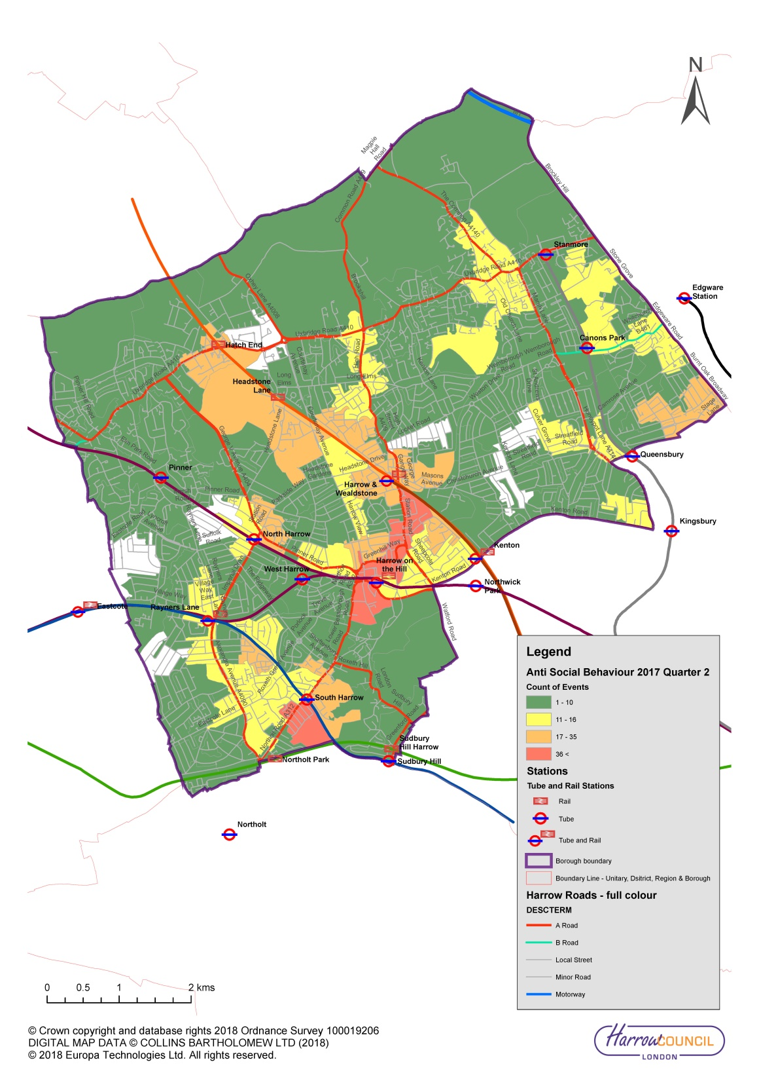

    - To improve road safety for children in Harrow schools, Harrow will do the following:
  - Provide road safety education events at schools and colleges throughout the borough
  - Promote and deliver cycle training for children and adults who work, study or live in the borough
  - Work with TfL to ensure take-up of Children's Traffic Club, a London road danger reduction education resource for pre-schoolers
  - Work with TfL to ensure take-up of the Safety and Citizenship pre-transition safe and responsible behaviour sessions for Year 6 pupils
  - Work with TfL to ensure take-up of the Junior Travel Ambassador and Youth Travel Ambassador schemes, addressing transport and road safety issues in schools
  - Work with parking enforcement and police to enforce and promote safe driving and parking in school zones

    - To ensure that the roads in Harrow are best designed to improve safety, and that the appropriate road safety training is provided, Harrow will do the following:
  - Adopt a Vision Zero approach towards eliminating all road deaths and serious injuries by 2041
  - Employ a road danger reduction approach to design, using the streets toolkit for designers, Road Safety Audit, and Healthy Streets Check for Designers
  - Prepare a programme of 20 mph zones in the borough and incorporate these into schemes for future TfL funding
  - Ensure that all aspects of a safe environment, including improved lighting, better sight lines particularly for vulnerable road users and well-lit waiting areas, are effectively considered when delivering works for all new schemes
  - Where possible use engineering solutions to minimise the need for additional road safety enforcement
  - Maintain an effective method of accident monitoring for the borough
  - Use accident statistical data to recognise trends and deliver targeted educational and engineering initiatives, with a focus on roads with a higher risk of motorcyclist collisions
  - Reduce the number of motorcycle casualties in the borough through road safety educational campaigns
  - Support the police in targeting illegal and non-compliant behaviour that puts motorcyclists at risk, using data to focus on the roads with a higher risk of motorcyclist collisions
  - Educate road users on the shared responsibility for safer motorcycle journeys, through driver and motorcyclist skills training and communications
  - Promote Motorcycle Industry Association (MCIA) accredited training providers to motorcyclists looking to undertake Compulsory Basic Training
  - Provide BikeSafe vouchers for subsidised courses delivered by local Motorcycle Industry Association (MCIA) accredited training providers
  - Improve the safety of street design by following the design guidance set out in TfL’s Urban Motorcycle Design Handbook
  - Prioritise schemes that maximise casualty reduction predictions and pose the highest risk to vulnerable road users and in particular the numbers killed and seriously injured per annum for the available finance
  - Encourage safe and considerate driving, at appropriate speeds, as part of travel awareness and road safety education campaigns and review existing speed limit to ensure they are appropriate to the location
  - Support the police in targeting illegal and non-compliant behaviour that places other road users at risk
  - Ensure that the safety concerns of all road users are considered when considering any traffic scheme
  - Carry out road safety audits of all new significant traffic and highway proposals.
  - Promote and deliver cycle training for children and adults who work, study or live in the borough
  - Deliver appropriate road safety interventions and resources for road users aged 60+ by targeting community groups, day centres and social clubs, facilitating bespoke workshops and presentations and providing road safety literature
  - Provide safe and secure cycle parking

    - To ensure that people in Harrow feel safe, the borough will do the following:
  - Work with TfL to improve the frequency and reliability of weekend and late night public transport services to/from Central London
  - Support the police to maintain focus on disrupting the criminal gangs involved in motorcycle theft and enabled crime
  - Work with the Metropolitan Police in using their powers of enforcement to deal with illegal cycling on pavements and footpaths
  - Work with schools and police to address perceptions of personal safety on buses
  - Work with GPS providers to ensure that freight routes are appropriately guided within the borough and avoid residential areas
  - Work with the Metropolitan Police to consider introducing traffic calming to lower speed and reduce impact of hostile vehicles in selected locations
  - Improve lighting across the borough by a change to LED lighting

Borough Objectives
    - The key borough objectives to deliver Outcome 2 are as follows:

- Improve the public realm through the introduction of healthy streets and liveable neighbourhoods to encourage active and safer travel particularly for pedestrians and cyclists thereby reducing congestion and improving public health and local air quality
- Adopt a Vision Zero approach towards eliminating all road traffic deaths and serious injuries by 2041 and focus on reducing the number of motorcycle casualties across the borough

Outcome 3: London’s streets will be used more efficiently and have less traffic on them

Challenges and opportunities
    - To reduce road traffic and use London’s streets more efficiently, a change in attitude to single car occupancy and driving short journeys are both needed as well as some increase in the available capacity on public transport. Harrow will work to encourage shorter journeys to be made by active travel - cycled or walked and this will enable bus capacity to be more appropriately used for longer journeys.

    - Census 2011 shows that around only 1% of working population (in employment and not working at home) cycle to work and 7% walk to work – yet 12% of the same population live less than 2km away from work and 16% between 2 and 5 km.

    - The latest modal split data for trips originating in Harrow by main mode is shown in Figure 10. This shows main mode for average day (7-day week) 2014/15 to 2016/17. The use of motorised transport needs to be reduced to enable Harrow to grow sustainably, to improve air quality and to reduce road traffic.

Figure 10: Harrow modal split 2014/15 to 2016/17
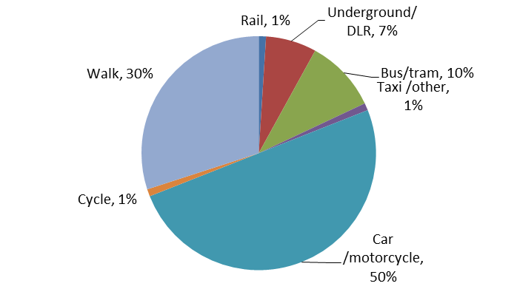
Source: Travel in London 10 supplementary information
Total trips per day 460,000

    - The most congested roads in Harrow are the A409, Marsh Lane/London Road/Stanmore Broadway in Stanmore, Marsh Road, Imperial Drive and Northolt Road. In all these locations, congestion issues will be addressed through managing the network performance and encouraging sustainable travel choices. In Northolt Road the congestion will also be addressed through introducing bus priority measures and removing some of the existing on-street parking. Figure 11 shows the average delays on Harrow roads between 7am and 10am between Jan 2016 and Nov 2016.

    - Reducing traffic levels will also improve the local air quality. Air pollution has a significant impact upon public health, with both short and long term health effects increasing the risk of conditions such as asthma, cardiovascular, and respiratory disease, as well as risk of death. Reducing the rate of NO₂ across the borough to under 20.5μg/m³ over the next ten years could reduce the number of cases of asthma by 112 cases and diabetes by 437 cases per 100,000 population per year. Reducing PM2.5 rates to >12.3μg/m³ across the borough would reduce the number of cases of coronary heart disease by 462, cases of chronic obstructive pulmonary disease by 260, cases of stroke by 120, cases of diabetes by 466 and prevent 260 deaths per 100,000 population per year.

    - In order to discourage private car ownership, both on and off street car clubs are being encouraged by new developments in the town centre. These are being introduced through the planning process in exchange for a reduction in the availability of private parking and are funded by Section 106 development funding.

    - Another way that car ownership is being addressed in selected areas in the borough is through parking permit restrictions that are applied to some properties that are intended to be 'car free' or have a low parking provision and are in areas with good access to public transport. Blue badge holders may still apply for permits at these locations. These conditions or agreements are applied at the time planning permission was approved for the development or conversion of a property.

    - The borough will also introduce parking control schemes to enable increased parking restraint measures and to encourage greater use of sustainable transport modes. This will increase the number of people walking and cycling and lead to more active and healthy lifestyles.

    - Congestion and efficiency are being addressed in the borough through improved parking layout and providing appropriate parking and loading facilities across the borough thereby reducing obstructive and illegal parking as well as reducing wasted travel by vehicles searching for spaces to park or load vehicles. In residential areas, controlled parking zones (CPZs) are introduced to ensure that there is sufficient parking available for those with disabilities, to support local businesses and to enable appropriate servicing and delivery where needed. CPZs incorporating residents parking schemes improve safety, access and residential amenity and assist management of parking in town centres to ensure more short stay shopper / visitor spaces are available. in Harrow will be standardising the operational hours of CPZs across the borough to change away from one hour only for all areas and making the operational hours appropriate for the busiest times of the zone.

    - Badly managed parking regulations can result in inefficient road use and as mentioned can also result in increased congestion and drivers wasting journeys looking for parking spaces or places to park or load. There is also an economic impact of poorly managed parking with time wasted by delivery services unable to park near their destinations or taking too long stuck in congestion. This is not only inefficient, but also costly and frustrating. Well managed parking regulations can both reduce wasted journeys and encourage the use of “greener” vehicles.

    - Following the Harrow Council move to its new site in 2021, the travel plan for the new premises will include car pools which will be available for necessary car journeys and will be used as an economic alternative to private car use. This will reduce car use by Council officers.

    - Harrow is collaborating with WestTrans in developing a freight heat map which will enable the borough to be better informed about the parking and loading needs of freight in the borough. Improving the parking and loading needs for freight vehicles will also help reduce congestion caused by illegal parking.

    - Another way congestion is addressed in the borough is through promoting sustainable travel choices and reducing the need to travel by car. Requiring development and regeneration to be situated in places best served by public transport and with appropriate facilities for sustainable travel choices will help to address some congestion issues.

Figure 11: Average delays on Harrow roads (7-10am) (Jan 2016 to Nov 2016)
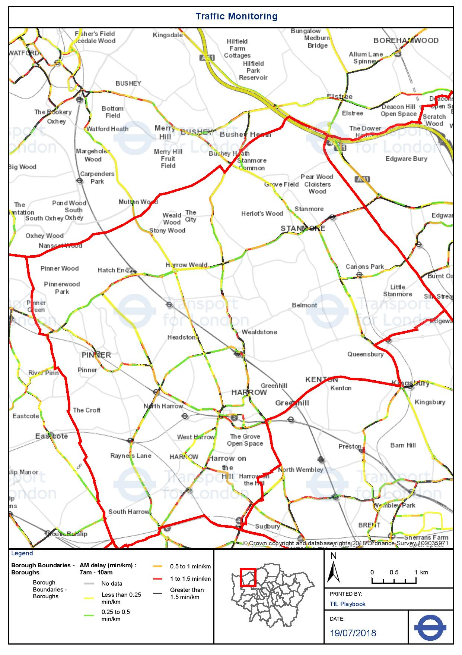

    - In 2012 Harrow introduced a borough freight strategy. This enabled the borough to prevent some heavy goods vehicles from cross cutting through local roads in the borough as a shortcut to reach destinations beyond Harrow. This significantly reduced heavy goods vehicles misusing local roads in the borough. The borough will continue to consider introducing and enforcing weight restrictions and road width restrictions to prevent the misuse of roads by inappropriate vehicles.

    - Harrow supports the London Lorry Control Scheme (LLCS) which controls the movement of heavy goods vehicles over 18 tonnes. The LLCS operates at night and at weekends on specific roads in London helping to minimise noise pollution. Harrow will support the continuation and effective enforcement of the London Lorry Ban.

    - Well-designed freight delivery servicing facilities can help reduce traffic. To ensure this happens, Harrow will do the following:
- Ensure that freight movement, delivery and servicing within the borough is provided for in an environmentally sensitive, economic and efficient manner and ensuring appropriate routing avoiding residential areas while reducing impacts and conflicts with other modes, for example bus lanes, cycle lanes
- Periodically review the provision in town centres and the Harrow Opportunity Area for all aspects of servicing, delivery, loading/unloading and freight movement, with particular regard to its impact on all other modes of transport, the local economy and the local environment
- Seek to provide adequate delivery and servicing access to shops, businesses and residential premises and in particular to provide convenient on-street short-stay spaces for servicing / delivery vehicles
- Produce and publish a map setting out key information in respect of restrictions on lorry movement within the borough, in terms of:
· Width, weight and length restrictions
· Low bridges
· Loading bans
· Access restrictions, including pedestrian areas
· Preferred routes for lorries
- Work with WestTrans to develop a freight heat map enabling the borough to be better informed about the parking and loading needs of freight in the borough
- Require, as a condition of securing planning permission, that development proposals make proper off-street provision for servicing and loading/unloading within the development site, in such a way that all vehicles entering or leaving a site are enabled to do so in a forward gear
- Support and seek, via the responsible regional/subregional authorities, appropriate sub-regional provision of break-bulk, consolidation, distribution and modal-transfer facilities for freight management, and appropriate and effective access to those facilities from the borough
- While recognising that road transport will remain the basis for freight movement, delivery and servicing provision within Harrow, Harrow will promote and maintain local area lorry bans together with supporting initiatives to move freight by non-road transport modes
- Use the planning process on major planning applications to require a Construction Logistics Plan that reduces the environmental impact through the use of lower vehicle emissions and reduced noise levels; improves the safety of road users; reduces vehicle trips particularly in peak periods and encourages efficient working practices

    - To address congestion in the borough, Harrow will do the following:
- Maximise the efficiency and reliability of the operation of the road network through methods outlined further in Harrow’s Highway Network Management Plan
- Reduce traffic volumes on local roads through traffic management techniques and where possible by diverting traffic to main arterial/distributor roads
- Work with schools to consider staggering school end times by a variety of measures including encouraging more school to introduce before and after school activities
- Give high priority to the enforcement of parking and road traffic regulations, particularly to those affecting the safety of all road users, reliable operation of bus services and the prevention of traffic congestion
- Monitor and review the provision and operation CPZs in all areas of the borough experiencing on-street parking stress and install new CPZs subject to, demand and consultation with the local community
- For new CPZs, and as CPZs are reviewed, change the operational hours of enforcement to target the busiest times of the location
- Review the parking regulations in the Opportunity Area to ensure that the needs of planned growth are appropriately addressed
- As reviews of CPZs take place, progressively enable the provision of business parking permits in CPZs for vehicles where permits are required as a major part of the operation of the business and where such journeys are not viable without
such parking permits

    - To reduce traffic on roads in Harrow, the borough will do the following:
- Encourage modal shift towards more sustainable forms of transport
- Provide effective alternatives to the car to encourage modal shift
- Increase provision for non-motorised modes of travel including cycling on all local access roads and treating walking as a priority travel mode, to be treated on a par with other means of transport
- Work with schools to reduce the number of school trips made by car
- Liaise with schools regarding suggested highway works required in school locality
- Promote and support the development of travel plans in accordance with TfL guidelines either for individual organisations or on an area wide basis as appropriate
- Promote sustainable and healthy travel choices through the use of school travel planning, travel awareness campaigns, cycle training and an improved walking environment
- Secure deliverable Travel Plans for major trip generating development

    - To ensure that parking is managed efficiently in the borough, Harrow will do the following:
- Ensure that charges for parking support the economic vitality of all town centres
- Promote and secure the adoption of consistent and complementary strategies at national, regional, London, sub-regional and neighbouring local authority levels and through the restraint-based car-parking standards
- In the development and operation of parking schemes and to ensure transparency, the council will follow the guidelines as outlined in the parking management strategy which will be regularly reviewed and updated
- Support local businesses by giving priority to short stay on-street parking and by discouraging long-stay parking
- Ensure that charges for off-street parking:
    - Support the economic vitality of all town centres
    - Finance progressive improvements to the standards of the council owned car parks
    - Maintain price competitiveness with comparable privately operated car parks
    - Encourage short stay parking with rapid turnover of spaces and deter long-stay parking where appropriate
    - Reduce the demand on surrounding on-street pay and display parking
    - Are set with the aim of car parks being 85% full in peak periods
    - Are self financing
- Where practicable, seek to secure consistent cross-boundary parking charges in conjunction with neighbouring authorities
- Encourage the use of cleaner and more environmentally friendly vehicles through prioritising specific facilities for parking of “greener” vehicles at all council owned car parks, e.g. providing specific locations for parking providing charging points for electric vehicles
- Give high priority to the enforcement of parking and road traffic regulations, particularly to those affecting the safety of all road users, reliable operation of bus services and the prevention of traffic congestion
- Monitor and review the provision and operation CPZs in all areas of the Borough experiencing on-street parking stress and install new CPZs subject to, demand and consultation with the local community
- Where alternative options exist, prevent or deter parking on footways and verges ensuring that the safety and convenience of pedestrians, the visually impaired and disabled people is paramount

Borough Objectives
    - The key borough objectives to deliver Outcome 3 are as follows:

- Improve the public realm through the introduction of healthy streets and liveable neighbourhoods to encourage active and safer travel particularly for pedestrians and cyclists thereby reducing congestion and improving public health and local air quality
- Increase the number of people cycling in the borough in order to improve public health, improve air quality, reduce congestion and to reduce the impact of climate change
- Improve freight servicing and delivery arrangements to reduce congestion and delays on the network

Outcome 4: London’s streets will be clean and green

Challenges and opportunities
    - Harrow is in a privileged position in London, in that it contains a substantial amount of accessible open space, extensive areas of Green Belt and also some attractive and unique historic neighbourhoods. Change, as well as growth, needs to be managed in a way that respects local character and heritage, and also enhances it whenever possible. New development, public realm improvements, as well as issues such as air quality need to be dealt with carefully to ensure Harrow remains an attractive place to live and work.

    - Climate change is predicted to increase global temperatures, and could also lead to increased flooding. Harrow therefore needs to reduce its carbon dioxide emissions and its impact on the environment in general, to contribute to climate change mitigation, whilst at the same time adapting the built environment to become more resilient to the effects of climate change. This includes flood resilience measures being designed into developments, and other sustainable construction techniques being encouraged, whilst protecting the heritage around us. Secondly, lifestyles have to become more sustainable and so issues such as reducing car travel, tackling waste and increasing the provisions for recycling need to be addressed.

    - In 2017/18 Harrow introduced its first ultra-low emission zone, neighbourhood of the future (NOF) in Harrow town centre. Measures included in the zone are:
- amending parking policies to incentivise Ultra Low Emission Vehicles (ULEV) ownership and providing parking discounts
- providing increased charging infrastructure in destination car parks near to the two main shopping areas of St Ann’s and St George’s shopping centre
- providing free credited training to mechanics in the area to ensure ULEVs can be safely and easily serviced
- up skilling local mechanics to support local businesses, making Harrow a centre of excellence for ULEV servicing and maintenance and boosting the local economy
- enabling businesses based in the borough to trial Low Emission Vehicles (LEVs) for their fleets, implementing a long term behaviour change strategy to raise awareness of the benefits of LEVs and overcome any misconceptions.

    - Harrow is considering restricting private cars from accessing Station Road/College Road and allowing only ULEVs access into the zone. The borough is researching current road signage issues that limit the borough’s ability to do this.

    - Based on the success of the Harrow NOF, Harrow is now considering the delivery of more NOFs across the borough.

    - Harrow intends to develop a broader borough wide policy to address the need to increase the uptake of electric vehicles in the borough. A lack of off-street parking in some residential areas prohibits uptake of electric vehicles due to the inability to safely charge vehicles while off-street. An electric vehicle borough policy will help identify locations where electric vehicle charging facilities will be most beneficial for both private residential areas and in commercial centres such as shopping centre car parks. It will also help identify appropriate locations for rapid charging infrastructure.

    - The Harrow Council vehicle depot is currently being redeveloped. Vehicles using the depot are refuse and recycling vehicles, school buses and pool cars. The new depot facilities will include up to 40% electric vehicle charging points for service vehicles. Harrow Council buses are currently Euro V and Euro VI diesel but the borough will have a full fleet of Euro VI diesel vehicles by early 2019. Refuse vehicles are Euro V but the borough will have a full fleet of Euro VI vehicles by early 2019. Tipper and pool cars are planned to switch to a combination of diesel and electric vehicles by 2020. The new depot is scheduled to be complete by 2020.

    - Potential flooding in the borough is being addressed through a variety of measures. These include using the planning process to ensure surface water from developments is restricted; creating flood storage areas; silt and vegetation management on watercourses; maintaining kerbside gullies and improving and maintaining flood defence structures along Harrow’s water courses.

    - For new developments, the discharge rate is restricted to the Greenfield run off rate. This is achieved through combination of various Sustainable Drainage System (SuDS) features which include green roofs, balancing ponds, rain gardens, swales and attenuation tanks.

    - The borough actively creates surface flood storage areas and river restoration in parks and open spaces. In addition to flood protection these also improve water quality; and by creating new and varied habitat also increase biodiversity. This also improves resilience to climate change by reducing flooding. These projects improve public amenity, provide educational opportunities and encourage public engagement and volunteering.

    - The borough has a kerbside gulley cleansing programme which is targeted to ensure cleansing frequencies are appropriate for each road. Watercourse trash screens are categorised into weekly, monthly or quarterly cleansing regimes.

    - Lighting across the borough is being improved by a change to LED lighting. This will ensure that the levels of lighting wherever needed are brought up to the necessary standards. The levels of lighting will be further enhanced by the use of higher output units in locations such as major junctions and crossing points. This will also drive a reduction in the volume of energy consumed to ensure that the borough works to meet the Government’s and the Mayor’s green agenda. The change to LED lighting is being based upon changing the oldest stock first. For the oldest stock, this includes changing the entire lighting installation.

    - Trees in the borough provide a range of environmental, economic and social benefits to Harrow residents. On a practical level trees help to mitigate and adapt to climate change and improve air quality. Trees are good for the environment as they absorb carbon dioxide as they grow and the carbon that they store in their wood helps slow the rate of global warming. Trees also help prevent flooding and soil erosion, absorbing thousands of litres of stormwater.

    - The residents of Harrow are fortunate to have a significant amount of mature tree cover across many parts of the Borough. Trees are also particularly good for the physical and psychological wellbeing of all those who visit areas where they grow. The borough aims to undertake to annually plant more trees than are removed. To ensure that Harrow benefits from additional trees, the borough will do the following:
- Increase the amount and variety of trees and plants across the borough's open spaces and within streetscapes
- Seek opportunities for new tree planting in the Opportunity Area

    - Harrow is concerned about the impact of new heavier buses on the Harrow road network. Newer heavier buses have a detrimental impact on the road network and the frequency that roads need to be repaired. Despite the new buses being ‘greener’, they have a local environmental impact in terms of road material replacement frequency and requirements. In addition, Harrow is not always informed in advance about bus frequency changes or bus model changes.

    - Delivering a high quality public realm increases the attractiveness of the streets, supports local shops and businesses and can enhance personal safety. Cleaner and greener environments are also crucial to enabling healthier communities.

    - To improve local air quality, reduce traffic noise and encourage the use of more environmentally friendly vehicles, the borough will do the following:
- Continue to support the Harrow town centre neighbourhood of the future and deliver new NOFs across the borough
- Provide reduced cost parking permits for appropriate greener vehicles
- Provide additional public electric charging points at key locations and consider the provision of rapid charging points to assist taxis, freight vehicles and car clubs
- Review the viability of introducing a revised parking permit structure based on vehicle emissions
- Encourage the use of cleaner and more environmentally friendly vehicles through prioritising specific facilities for parking of “greener” vehicles at all council owned car parks, e.g. providing specific locations for parking by providing charging points for electric vehicles
- Request all providers or users of Council transport fleets to consider how they can move towards the use of less polluting vehicles
- Work with schools to identify local air quality issues surrounding schools and where appropriate access the Mayor’s Air Quality Fund to provide appropriate solutions and raise awareness of the issue
- Use new polymer modified materials with EME material (Enrobé a Module Élevé) a derivative for use on bus stops where there is heavy static loading and low speed heavy movements for road surfacing to reduce noise, increase durability and increase the roads lifespan. New materials and better road conditions can reduce noise by up to 20%
- Maximise procurement opportunities for Small and medium-sized enterprises (SMEs) and local suppliers to minimise supply chain journeys

    - To enable Harrow to deliver a cleaner and greener environment, Harrow will do the following:
- Improve the environment for pedestrians and cyclists in the whole borough and particularly within the Harrow Opportunity Area
- In all new neighbourhood schemes the borough will consider the Healthy Streets checklist
- Ensure that all schemes implemented follow the Harrow street furniture design guide ensuring best practice for materials and reducing street clutter
- Improve on the condition of Harrow roads by continuing to prioritise road maintenance in Harrow’s capital and revenue budgets in line with best practice asset management principles
- Ensure all projects consider their air quality and noise impact and that where possible mitigation is introduced to minimise adverse impacts
- In all liveable neighbourhoods schemes the borough will consider planting and street greening to provide shade and shelter and to create a more attractive environment
- Improve pedestrian and cycle wayfinding across the borough and work with TfL to expand Legible London in Harrow
- Raise awareness among residents about the planning requirements around paving over front gardens and opportunities to use permeable surfacing
- Support the introduction of rapid electric charging facilities for freight, taxis and car club vehicles to enable the introduction of Zero Emission Capable (ZEC) taxis
- Use the planning process to ensure that the discharge rate for new development is restricted to the Greenfield run off rate using various SUDS measures
- In addition to flood protection, create surface flood storage areas in parks and open spaces to improve water quality and increase biodiversity
- For all new schemes, review opportunities to introduce rain gardens, additional trees and protect existing grass verges to increase local biodiversity. Wherever practicable grass verge areas will be introduced and extended to ensure that the maximum amount of water will be contained within the highway area to percolate through to the sub-soil, rather than in to the local sewer system

Borough Objectives
    - The key borough objectives to deliver Outcome 4 are as follows:

- Improve the public realm through the introduction of healthy streets and liveable neighbourhoods to encourage active and safer travel particularly for pedestrians and cyclists thereby reducing congestion and improving public health and local air quality
- Increase the number of people cycling in the borough in order to improve public health, improve air quality, reduce congestion and to reduce the impact of climate change
- Encourage the uptake of more sustainable modes of travel through active travel initiatives, delivering additional healthy routes to school, promotion of cycle hire schemes, the use of parking and permit policies and prioritising road space to walking and cycling to improve the environment.
- Encourage the uptake of ultra-low emission vehicles instead of fossil fuel powered vehicles through the use of promotional activities, increased Ultra Low emission zones, neighbourhoods of the future, and greater availability of electric charging facilities, thereby improving air quality, reducing traffic noise and reducing CO₂ emissions throughout the borough
- Ensure that the vitality of all town centres are supported through good transport links prioritising sustainable modes of transport
- Prioritise sustainable travel improvements for all new developments to support population growth and housing needs identified in the London Plan and local development framework

Outcome 5: The public transport network will meet the needs of a growing London

Challenges and opportunities
    - Harrow’s population is growing and the demographic of residents is changing. Households are getting smaller, life expectancy is anticipated to increase, and technological advances are changing the way people live, travel and work. Harrow residents enjoy good life expectancy (82.7 years for men and 86.1 years for women) resulting in a disproportionately high increase in the proportion of older residents and adults living alone. It is expected that the number of residents aged 65 plus will increase by 42% and those aged 85 plus could increase by 62% by 2029.

    - A lack of good transport options can be a significant barrier to social inclusion and independence. Because older people are more dependent on public transport, they suffer more than most from poor public transport and a badly maintained transport infrastructure. The Borough will also see a growth in the under 15 age group (9.8%) which will also need to be considered regarding their future transport needs.

    - Although many older residents in the borough remain independent, there is undoubtedly a need to ensure that the public realm is both welcoming and accessible to meet their needs and the needs of all those who face similar obstacles. To address these issues, Harrow will do the following:
- Work with TfL to improve the penetration and expansion of local bus services into every local neighbourhood area – either by extending existing routes or, where necessary, by promoting new routes – this will be subject to the evaluation of the local impact of any additional bus services
- Persuade TfL to concentrate on continuing to improve public transport service reliability ensuring improved radial and orbital services
- Work with TfL to improve bus service reliability and to improve orbital bus links between the town centres and major employment locations and to other key destinations within Harrow and neighbouring boroughs
- Review cycle parking on station land particularly at Harrow and Wealdstone, Harrow on the Hill station, Stanmore and Rayners Lane stations
- Work towards introducing a fully integrated, accessible bus and underground station at Harrow on the Hill
- Consider the provision of additional seating in all new schemes to benefit the needs of those with mobility difficulties, giving particular consideration to road side seating in areas beyond the town centres which would enable many people to take short walking trips outside their own homes
- In partnership with public transport service providers and regulators, seek to ensure that all stations and bus stop locations in the borough are progressively improved with the intention of developing at access points, if appropriate, a fully wheelchair-accessible boarding / alighting points, as a basis for supporting a network of fully wheelchair-accessible scheduled bus services
- Improve transport connectivity within the Opportunity Area between Harrow Town Centre and Wealdstone including the provision of in station cycle parking
- Work with the key regulators and providers of rail, Underground and bus services within the borough to progressively improve the network in terms of capacity and reliability.
- Build on existing liaison arrangements with those parties responsible for regulating and operating public transport services in the borough – issues discussed will include concerns of public transport users with both TfL bus and all rail operators and will include bus driving standards, bus emissions, driver behaviour, bikes on buses and trains, as well as general service provision
- Seek to secure a fully integrated approach to the provision and operation of public transport services within Harrow, including:
    - Improving the ease and convenience of approach routes to service access points, and the quality and clarity of the access signing
    - Taking account of the specific needs of people with impaired sight or impaired mobility
    - Improved taxi facilities at rail and underground stations
- Support the extension of additional taxi rank operational hours where this supports late travel such as the night time running of the Jubilee Line

Borough Objectives
    - The key borough objectives to deliver Outcome 5 are as follows:

- Encourage the uptake of more sustainable modes of travel through active travel initiatives, delivering additional healthy routes to school, promotion of cycle hire schemes, the use of parking and permit policies and prioritising road space to walking and cycling to improve the environment.
- Support improved orbital transport links across the borough and between outer London centres to provide wider access to employment opportunities and to enable journeys currently made by car to be made by sustainable forms of transport and thereby improve the environment
- Improve transport connectivity throughout the Harrow and Wealdstone Opportunity Area and particularly between Harrow-on-the-Hill station/ Harrow bus station and Harrow & Wealdstone station
- Ensure that the vitality of all town centres are supported through good transport links prioritising sustainable modes of transport
11. Prioritise sustainable travel improvements for all new developments to support population growth and housing needs identified in the London Plan and local development framework
- Prioritise the transport needs of the Harrow and Wealdstone Opportunity Area

Outcome 6: Public transport will be safe, affordable and accessible to all

Challenges and opportunities
    - For many years, Harrow has been lobbying for improved accessibility at Harrow on the Hill station. Step free access is now being introduced at the station and is scheduled to be completed by 2020. This is a major victory for accessibility in Harrow town centre. Further underground accessibility improvements are required at Stanmore, Rayners Lane and Canons Park stations. Stanmore station has some accessibility through the car park but it is far from adequate.

    - Harrow was one of the first boroughs in London to introduce an audit of bus stop accessibility and has continued to progress with improving accessibility levels. 99% of bus stops in the borough are now accessible.

    - To support those with mobility difficulties, Harrow Council provides the Freedom Passes, Blue Badges and Taxicards enabling concessionary transport services for eligible residents. Freedom Passes allow free travel in the Greater London area on buses, tube, national rail (London network), DLR and Tramlink, for older and disabled people who reside in the borough. They also allow free bus travel on local bus services anywhere in England. The Blue Badge scheme gives free and dedicated parking close to amenities for drivers and passengers with mobility related disabilities, or who are blind. Taxicards are made available to those with serious difficulties with walking (including breathing problems and sight loss) to travel in taxis at reduced rates.

    - Harrow Community Transport has been provides community transport services for those in Harrow with mobility needs. Their service is provided to local community and voluntary groups in the borough. They are a charity funded through donations and deliver essential services in both the London boroughs of Harrow and Brent. They also provide Group Transport, Individual Transport, Community Car Service (CCS), Driver Training - MiDAS (Minibus Driver Awareness Scheme), Technical Advice / Vehicle Management and Contract Services.

    - To support those with mobility difficulties in Harrow and to improve the safety and accessibility of travelling in Harrow, the borough will do the following:

- Adopt a Vision Zero approach towards eliminating all road deaths and serious injuries by 2041
- In the development of parking schemes, the council will ensure convenient car parking for people with disabilities is considered
- Ensure adequate provision of blue badge parking is available in all town centres
- In partnership with public transport service providers and regulators, seek to ensure that all stations and bus stop locations in the borough are progressively improved with the intention of developing at access points, if appropriate, a fully wheelchair-accessible boarding / alighting points, as a basis for supporting a network of fully wheelchair-accessible scheduled bus services
- Work towards introducing a fully integrated, accessible bus and underground station at Harrow on the Hill
- Petition TfL to improve the accessibility of all stations in the borough where there is no disabled access
- Seek to ensure that all stations and bus stop locations in the borough are progressively improved as a basis for supporting a network of fully wheelchair-accessible scheduled bus services
- Liaise with the Public Carriage Office regarding improving the accessibility of taxi ranks in the borough
- Continue to support of the expansion of the Harrow Shopmobility services and their opening hours
- Work with schools to promote travel training for children and young people with learning difficulties
- Work with Harrow Association of Disabled People and other disability organisations to address a range of accessibility issues

Borough Objectives
    - The key borough objectives to deliver Outcome 6 are as follows:

- Adopt a Vision Zero approach towards eliminating all road traffic deaths and serious injuries by 2041 and focus on reducing the number of motorcycle casualties across the borough
- Improve public transport accessibility, support the expansion of bus and rail services throughout Harrow and in particular, support increased bus priority to deliver a more reliable, faster and more accessible public transport experience

Outcome 7: Journeys by public transport will be pleasant, fast and reliable

Challenges and opportunities
    - Harrow will continue to liaise with TfL and public transport operators and user groups through its regular public transport liaison group meetings. Reviews of bus routes and other issues that affect all public transport provision in the borough are considered at these meetings.

    - Harrow liaises with TfL about the transport needs of the borough but has limited influence over the services actually run. As TfL faces significant funding restrictions, the borough is concerned that this might result in cuts to local bus services in terms of bus routes and bus frequency. If this were to happen, then overcrowding would become a greater issue and the necessary public transport support for new growth areas would not be provided. In addition, the new orbital bus services needed in Outer London would not be delivered.

    - The reliability of bus routes can be improved by good design, better managed roadworks and well managed kerbside space through appropriate parking regulations. Introducing appropriate bus priority including additional bus lanes, bus gates, introducing signal reviews, changes to bus lane operational hours and accessible bus stops can all improve the reliability of the bus service. In addition, the importance and reliability of the bus service is always considered in managing the road network in the borough. Enforcement of road traffic, parking and waiting regulations need to be considered in the interests of improving bus priority and where possible engineering solutions need to be used to minimise the need for any additional enforcement.

    - To support buses and taxis to provide a pleasant, fast and reliable service, Harrow will do the following:
- Deploy full range of available bus priority measures ensuring that measures are designed to reduce problems for all modes
- Work with TfL to prioritise available resources to provide the road space and traffic regulatory / management infrastructure to support development of the bus services as well as additional bus services
- Seek to work with public transport providers and regulators to ensure that engineering works and service closures are coordinated to minimise passenger inconvenience
- Enforce all road traffic, parking and waiting regulations in the interests of improving bus priority. Where possible engineering solutions will be used to minimise the need for additional enforcement.
- Work in partnership with public transport service providers and regulators, seek to ensure that all stations and bus stop locations in the borough are progressively improved to offer a safe, secure and passenger-friendly environment and appropriate ‘state-of-the-art’ passenger interchanges
- Seek to ensure that all stations and bus stop locations in the borough are progressively improved as a basis for supporting a network of fully wheelchair-accessible scheduled bus services
- Liaise with the Public Carriage Office regarding improving the accessibility of taxi ranks in the borough
- Support improved orbital transport links across the borough and between outer London centres to provide wider access to employment opportunities and to enable journeys currently made by car to be made by sustainable forms of transport and thereby improve the environment
- Work with TfL and bus operators to ensure adequate off-highway facilities are available for the storage and maintenance of buses at appropriate locations and to ensure that bus stands are appropriately located

Borough Objectives
    - The key borough objectives to deliver Outcome 7 are as follows:

10. Improve public transport accessibility, support the expansion of bus and rail services throughout Harrow and in particular, support increased bus priority to deliver a more reliable faster and more accessible public transport experience
- Keep the transport network in good condition and serviceable to encourage the use of sustainable transport modes

Outcome 8: Active, efficient and sustainable travel will be the best option in new developments

Challenges and opportunities
    - The London Plan parking standards are used to drive down car ownership in the borough and to increase cycle parking facilities. The standards ensure that new developments of various types contain high levels of access to cycle parking. Harrow will be developing a new transport Supplementary Planning Document (SPD) to support the Local Plan and to better explain and enable the borough to enforce the need for of reduced car ownership through the planning process. The SPD is likely to include threshold information on parking requirements for residential and non-residential developments, details on travel plan requirements and travel plan bonds, cycle storage and parking as well as specific information on assessing restaurants and takeaways and the development of residential garages.

    - The Harrow and Wealdstone Opportunity Area in the centre of the borough will be the focus for borough regeneration, providing for a significant portion of new development and include much of the borough growth in population, housing and employment within the borough. An Area Action Plan for the Opportunity Area has been developed and to support this growth, the area will need to be the focus of many new transport initiatives in the borough. Other areas of growth across the borough will be directed to town centres where additional transport needs will also be considered.

    - Harrow has developed high quality town centre design standards and also a materials pallet that are being used for the Harrow and Wealdstone Opportunity Area. These higher standards will be rolled out to other areas where regeneration occurs.

    - To ensure that growth in Harrow is sustainable, Harrow will do the following:

- Promote growth in areas of greatest public transport to encourage residual travel by public transport, walking and cycling
- Consider the improvement of local access by walking, public transport, motorcycling and cycling as a core element in future regeneration programmes for local centres and employment areas
- Promote mixed use development in growth locations to reduce the need to use a vehicle for trips between residential, retail, leisure and employment areas
- Consider the improvement of local access by walking, public transport, motorcycling and cycling as a core element in future regeneration programmes for local centres and employment areas
- Seek to ensure that new facilities to reduce car dependency e.g. real time public transport information and shopping lockers are placed in shopping centres
- Work with the Mayor, the GLA and the Government to pursue the progressive removal / control of “free” parking – through planning agreements (new development), through voluntary initiatives (retail partnerships) or by extending the principle of charging for car parking spaces
- Where accessibility by non-car modes is particularly good or can be made so, the council will actively seek to secure lower levels of car parking provision or even zero provision in developments, and require the completion of a binding agreement to introduce residential permit restrictions on the developments to limit the increase in car use and ensure that any measures necessary to improve accessibility by non-car modes are secured
- For new larger developments, use travel plan bonds, for failure to meet performance of agreed travel plans and secure Developer funding to pay to monitor the travel plans; monitoring will continue for at least five years following development completion
- In preparing Transport Assessments and Transport Statements to demonstrate sufficient/appropriate levels of car parking provision for location outside of high PTAL areas, trip generation data should be assessed alongside Census travel to work and car ownership data for the relevant ward or Middle Super Output Layer
- When considering housing developments the council will encourage developers to explore the potential for schemes to provide access to cars without individual ownership, possibly linked to inducements to use other modes
- Ensure convenient access for walking, cycling and public transport be required in the design and layout of new development
- Ensure that walking permeability (a multiplicity of routes to give easy accessibility to, from and within a site) is assessed and prioritised for all new residential or business developments
- Secure deliverable Travel Plans for major trip generating development
- Promote the use of travel plans for all educational establishments, hospitals and other places of work and where appropriate work with organisations to improve site specific travel plans
- Use its powers as local planning authority to make planning permission for future development conditional upon the availability of an appropriate level of pedal cycle parking and facilities such as showers and lockers and encourage provision of “cycle pools”
- Use the planning process on major planning applications for larger developments to require a Construction Logistics Plan that reduces the environmental impact through the use of lower vehicle emissions and reduced noise levels; improves the safety of road users; reduces vehicle trips particularly in peak periods and encourages efficient working practices
- Use Section 106 Planning Agreements to secure developer contributions towards the costs of meeting and ameliorating the travel demand generated by development through improvement to public transport, walking and cycling, installing parking controls and, where necessary, creating regulated and controlled public car-parks
- In considering planning applications for non-residential development the council will have regard to the specific characteristics of the development including provision made for:
  - Operational parking and servicing needs
  - Convenient car-parking for people with disabilities
  - Car parking related to shift and unsociable hours working
  - Convenient and secure parking for bicycles
  - Needs of parking for motorcyclists

Borough Objectives
    - The key borough objectives to deliver Outcome 8 are as follows:

- Improve the public realm through the introduction of healthy streets and liveable neighbourhoods to encourage active and safer travel particularly for pedestrians and cyclists thereby reducing congestion and improving public health and local air quality
- Increase the number of people cycling in the borough in order to improve public health, improve air quality, reduce congestion and to reduce the impact of climate change
5. Encourage the uptake of more sustainable modes of travel through active travel initiatives, delivering additional healthy routes to school, promotion of cycle hire schemes, the use of parking and permit policies and prioritising road space to walking and cycling to improve the environment.
- Prioritise sustainable travel improvements for all new developments to support population growth and housing needs identified in the London Plan and local development framework

Outcome 9: Transport investment will unlock the delivery of new homes and jobs’

Challenges and opportunities
    - London faces significant projected population growth (70,000 every year), reaching 10.5 million in 2041. This means that just to meet demand, at least 66,000 new homes need to be built in London every single year. In Harrow, the borough needs to build 13,920 new homes by 2028/29.

    - The borough needs to deliver new homes and jobs to meet the forecast growth in population. To deliver new housing and regeneration in Harrow, the borough will continue to work with TfL to pursue opportunities for mixed-use development and redevelopment in and around rail and bus stations. Harrow is already working in partnership with TfL reviewing TfL landholdings to improve efficiency use and identifying development opportunities around Harrow on the Hill station. In addition, the borough will seek contributions from developers through Section 106 agreements and using the Community Infrastructure Levy (CIL) for bus and cycle infrastructure improvements that will help support this growth.

    - Bus routes throughout the borough may need to be extended to ensure that the growth in population doesn’t result in a disproportionate and unsustainable growth in car use. Good bus services as well as walking and cycling facilities are all vital to unlocking the delivery of new homes and jobs in the borough. Where cars are needed, there needs to be a move to more sustainable vehicle choices supported through increased provision of electric charging facilities. This will all be assisted through the delivery of more liveable neighbourhoods and neighbourhoods of the future. Additional cycle routes and cycle parking at public transport interchanges and other key locations will also be needed to support planned growth.

    - Harrow supports the development of the West London orbital line. However the proposed route is unlikely to have a considerable impact on travel in the borough. The borough needs improved orbital links to increase access to employment opportunities. Harrow does have an excellent bus link to Heathrow airport. Bus route 140 offers a direct and high frequency service taking 75-100 minutes to reach the airport. The borough will work with TfL to assess suggested service improvements.

    - Figure 12 shows the planned growth areas in the borough.

Figure 12: Growth areas in Harrow
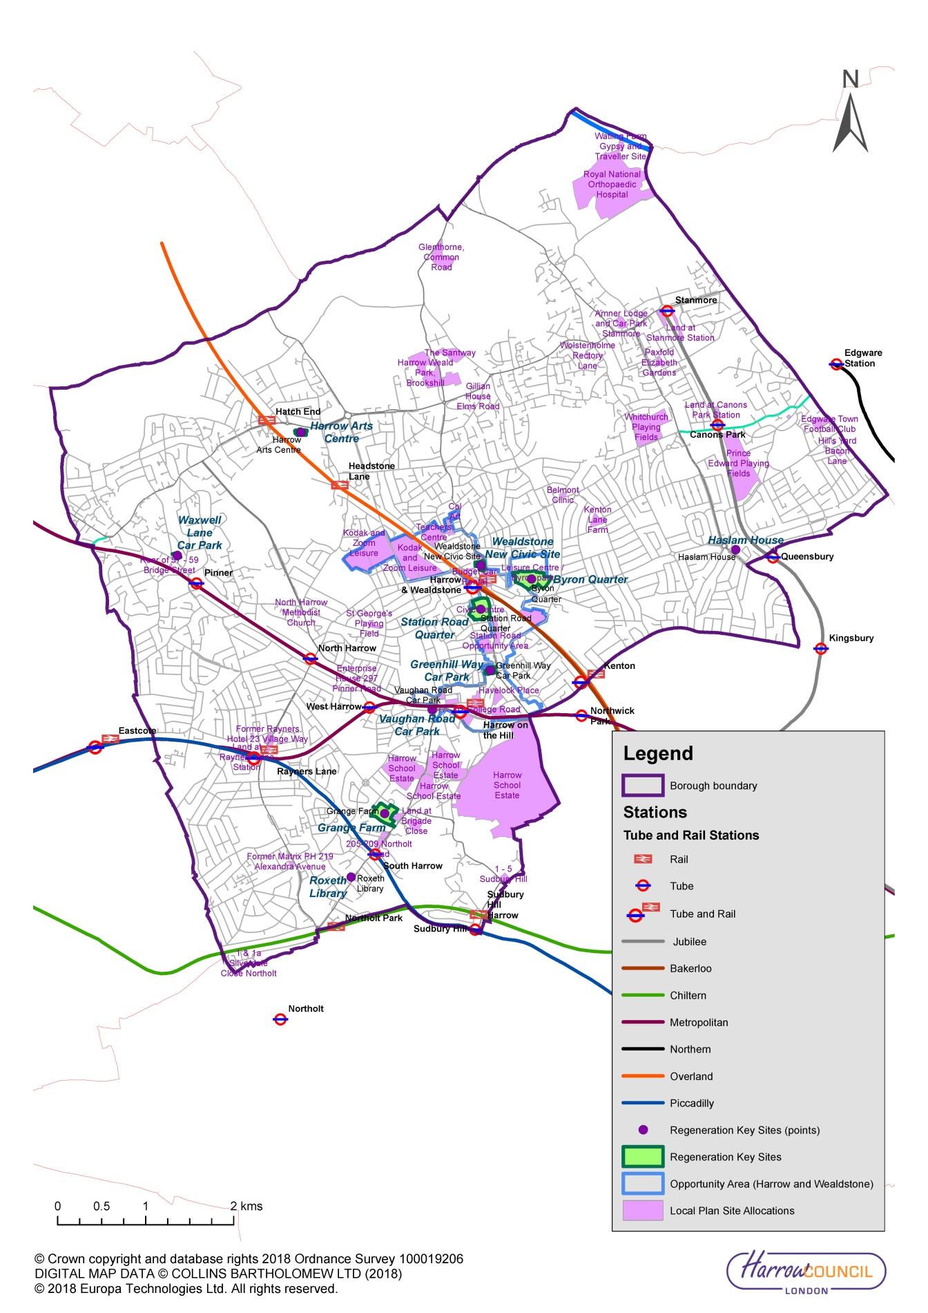

    - To support the delivery of new homes and jobs, Harrow will do the following:

- Support improved orbital transport links across the borough and between outer London centres to provide wider access to employment opportunities and to enable journeys currently made by car to be made by sustainable forms of transport and thereby improve the environment
- Work with TfL to assess suggested service improvements for the Heathrow bus link route 140 as well as any additional routes needed to support the proposed Heathrow expansion
- Review cycle parking on station land particularly at Harrow and Wealdstone, Harrow on the Hill station, Stanmore and Rayners Lane stations
- Review the level of cycle parking available across the borough
- Ensure the progressive delivery and maintenance of a high quality of cycle route provision, consistent with London Cycling Design Standards, as well as clear continuity and consistency in design; and ensure that, wherever practicable, provision is designed and implemented to cater for tricycles and bikes with trailers
- Publish and distribute cycling leaflets and maps in areas of the borough identifying the locations of designated cycle routes, cycle parking facilities, barriers to use and main road crossings
- Maximise training, apprenticeship and employment opportunities on all schemes to ensure residents benefit from the economic opportunities generated by transport infrastructure programmes and journey to work times are reduced

Borough Objectives
    - The key borough objectives to deliver Outcome 9 are as follows:

7. Support improved orbital transport links across the borough and between outer London centres to provide wider access to employment opportunities and to enable journeys currently made by car to be made by sustainable forms of transport and thereby improve the environment
11. Prioritise sustainable travel improvements for all new developments to support population growth and housing needs identified in the London Plan and local development framework
- Prioritise the transport needs of the Harrow and Wealdstone Opportunity Area
- Keep the transport network in good condition and serviceable to encourage the use of sustainable transport modes

Other Mayoral Strategies
    - The following Mayoral strategies were all considered in developing Harrow’s Transport Local Implementation Plan:

- The Mayor’s Transport Strategy, 2018
- Mayor’s Transport Strategy – Local Implementation Plan guidance, 2018
- Draft London Plan, Spatial Development Strategy for Greater London, 2017
- London Environment Strategy, 2018
- Economic Development Strategy, 2017-18
- Vision Zero for London, 2017
- Healthy Streets for London, 2017
- Better Environment, Better Health, 2013
- Mayor’s Climate Change Adaption Strategy, Managing risks and increasing resilience, 2011

    - The first three of these documents have been the key influences on developing the Harrow LIP3.

    - Table 3 shows the key influences from these documents.

Table 3: Key document influences on LIP3
Strategy | Key input into LIP3 | Sections of LIP3 most influenced
The Mayor’s Transport Strategy  And  Local Implementation Plan guidance | Driving force for all content – also an excellent source of background data and reasoning for policies | Development of all borough objectives  Development of policy to deliver Mayoral outcomes
Draft London Plan, Spatial Development Strategy for Greater London | Integration of land use and transport  Link between development and healthy streets indicators  Car and cycle parking standards for development | Development of borough objectives  Development of borough growth and parking policies
London Environment Strategy | Air quality, noise, biodiversity and climate change data and policies | Development of borough objectives  Details for environment content

    - The Mayoral policies listed all contain a range of ambitions and targets. Table 4 shows targets included in the documents that are most relevant to LIP3.

Table 4: Key ambitions and targets from Mayoral policy documents
Strategy | Relevant Key Targets / Ambition
The Mayor’s Transport Strategy  And  Local Implementation Plan guidance | Traffic  Reduce total London traffic by 10-15 per cent by 2041  80 per cent of all trips in London to be made on foot, by cycle or using public transport by 2041  By 2041, all Londoners to do at least the 20 minutes of active travel they need to stay healthy each day  Casualties  2022 – reduce the number of people who are killed or seriously injured by 65 per cent against 2005-09 levels  2030 – reduce the number of people who are killed or seriously injured by 70 per cent against 2010-14 levels  2041 – eliminate all deaths and serious injuries from road collisions from London’s streets  2022 – reduce the number of people who are killed or seriously injured in, or by, London buses by 70 per cent against 2005-09 levels  2030 – reduce the number of people killed in, or by, London buses to zero  Emissions  Make London’s transport network zero emission by 2050 including achieving a health-based target of 10μg/m³ for PM_{2.5} by 2030.  All new taxis to be zero emission capable from 2018 and all new Private Hire Vehicles (PHVs) from 2023, all new buses to be zero emission from 2025, all new cars and vans from 2030 and all other vehicles from 2040
Draft London Plan, Spatial Development Strategy for Greater London | 10 year targets for net housing completions (2019/20-2028/29)  10 year targets (2019/20 -2028/29) for net housing completions on small sites (below 0.25 hectares in size)  Make more than 50 per cent of London green by 2050
London Environment Strategy | Reducing construction traffic by five per cent by 2020, and reducing the number of freight trips during the morning peak by ten per cent by 2026  London to be zero emission city by 2050  Habitat creation targets including targets for species-rich woodland, flower-rich grassland, rivers and streams and for reedbeds  Increase the area of London under tree cover by ten per cent by 2050

The Delivery Plan

Introduction
    - This chapter sets out Harrow’s Delivery Plan for achieving the objectives of LIP3. It includes:
- Linkages to Mayor’s Transport Strategy priorities
- A list of potential funding sources for the period 2019/20 to 2021/22
- Proposed long-term interventions
- A three year indicative Programme of Investment for period 2019/20 to 2021/22
- A detailed annual programme for 2019/20

Linkages to the Mayor’s Transport Strategy priorities
    - The Delivery Plan has been developed to align the borough’s projects and programmes with the policy framework of the Mayor’s Transport Strategy, the overarching mode share aim, each of the nine outcomes, and the relevant policies and proposals. Table 5 shows the linkages between the LIP projects and programmes and the MTS outcomes.

Table 5: Linkages between LIP projects and programmes and the Mayor’s Transport Strategy outcomes (ST01)
Project / Programme |  | MTS mode share | MTS outcomes
 |  | Improving active, efficient and sustainable mode share | No 1:-Active | No 2:- Safe | No 3:-Efficient | No 4:- Clean & Green | No 5:- Connected | No 6:- Accessible | No 7:- Quality | Nos 8 & 9 Sustainable Growth/Unlocking
 | Corridors and supporting measures
1 | Road Safety Schemes (Vision Zero)
2 | Walking and Cycling Schemes
3 | Bus Priority Schemes
4 | Freight Management Schemes
5 | Congestion Relief Schemes
6 | Accessibility Schemes
7 | Shopmobility
8 | Travel Training
9 | ULEV and Air Quality
10 | Active and Sustainable Travel
11 | Road Safety Education
18 | Cycle Training
17 | Travel Plans
19 | Controlled Parking Zones
 | Major schemes
1 | Liveable Neighbourhoods

TfL Business Plan

    - Harrow is unique in London in that none of the Transport for London road network passes through the borough. Consequently, the borough is significantly less impacted than other boroughs by TfL plans.

    - None of the schemes identified by TfL as part of their transformational schemes, major schemes or cycle superhighways are within Harrow or will impact the borough.

    - Land by Harrow on the Hill station in the Harrow and Wealdstone Opportunity Area is being developed working in partnership with TfL to bring forward additional housing.

Sources of funding

    - Harrow parking revenue is used to support the Freedom Passes and Taxicard schemes. Harrow capital funds are used to support parking infrastructure management measures including CPZs. This is usually £300k per annum. In 2019/20 and 2020/21, around £500k of Harrow capital has also been used to support principal road maintenance and to address the removal of funding by TfL. It is not yet clear if this will continue into later years.

    - Table 6 identifies potential funding sources for implementation of LIP3, including LIP3 funding allocation from TfL, contributions from the borough’s own funds, and funding from other sources.

    - The key source of funding is the borough’s LIP allocation which is formula funding based on the following factors: local public transport (buses), safety, congestion, environment and accessibility. Figures provided by TfL indicate that the borough will receive £1,290.7k per annum, however this may change.

    - In addition to the above, the borough hopes to achieve TfL Strategic and Discretionary funding for liveable neighbourhoods, bus priority, road safety, cycle Quietway and MAQF. This funding is dependent on negotiations with TfL and successful bids.

    - The sums available from developers in Harrow via section 106 agreements are likely to be around £100k per annum.

    - Receiving the financial awards from TfL and the discretionary funding awards will make significant impact on the borough’s ability to deliver modal shift.

Table 6: Potential funding for LIP3 delivery (ST02)
Funding source | 2019/20 | 2020/21 | 2021/22 | Total
 | £k | £k | £k | £k
LIP Formula funding
Corridors & Supporting Measures | 1,290.7 | 1,290.7 | 1,290.7 | 3,872.1
GLA funding
Public Realm Good Growth  (Lyon Square) | 150 | 615 | 0 | 765
Discretionary funding
Liveable Neighbourhoods (Wealdstone town centre) | 200 | 2,000 | 2,000 | 4,200
Strategic funding
Bus Priority | 100 | 100 | 100 | 300
Road Safety | 100 | 100 | 100 | 300
Cycle Quietway | 1,500 | 1,500 | 0 | 3,000
MAQF | 100 | 100 | 100 | 300
Strategic funding Sub-total | 1,800 | 1,800 | 300 | 3,900
Borough funding
Capital funding (CPZs and Principal Road Maintenance) | 800 | 800 | 800 | 2,400
Borough funding Sub-total | 800 | 800 | 800 | 2,400
Other sources of funding
S106 | 100 | 100 | 100 | 300
Other funding Sub-total | 100 | 100 | 100 | 300
Total | £4,341 | £6,606 | £4,491 | £15,437

Long-Term interventions to 2041

    - Over the longer term, changes to improve Harrow that are needed to achieve significant benefits that will ensure the economic and social vitality of the borough are the delivery of more liveable neighbourhoods. Delivering more liveable neighbourhoods will enable a visible step change in the public realm and also has the potential to deliver significant environmental improvements. The areas chosen to deliver these have predominantly been based on the TfL Strategic Cycling Analysis of potentially switchable trips. These are shown in Table 7 with indicative funding and indicative but uncommitted timescales.

    - All new liveable neighbourhoods would address road safety and personal safety, improve accessibility, traffic calming, address environmental issues including air quality improvements, provide more trees, greenery and electric charging facilities, deliver shaded shelter, increased places to sit and socialise in the street environment, deliver improvements to the public realm that would encourage walking and cycling and improve the overall accessibility of the area. These will also be key in enabling the borough to deliver the required change to support the Mayor’s aims and priorities.

    - Introducing liveable neighbourhoods would also enable the borough to include increased localised active travel initiatives to better address health issues such as diabetes and obesity levels.

Table 7: Long-term interventions up to 2041 (ST03)
Project | Approx. date | Indicative cost | Likely funding source | Comments
Harrow and Wealdstone Town Centre Liveable neighbourhood | 2020-2025 | £5.0M | LB Harrow  TfL and developer contribution | To include active travel initiatives as well as liveable neighbourhood improvements (location identified as one where more cycle trips are possible)
Rayners Lane Liveable neighbourhood | 2022-2027 | £5.0M | LB Harrow  TfL and developer contribution | To include active travel initiatives as well as liveable neighbourhood improvements (location identified as one where more cycle trips are possible)
Stanmore Liveable neighbourhood | 2024-2029 | £5.0M | LB Harrow  TfL and developer contribution | To include improvements in accessibility to Stanmore station, active travel initiatives as well as liveable neighbourhood improvements
Edgware Liveable neighbourhood | 2026-2031 | £5.0M | LB Harrow  TfL and developer contribution | To include active travel initiatives as well as liveable neighbourhood improvements (location identified as one where more cycle trips are possible)
South Harrow Liveable neighbourhood | 2028-2033 | £5.0M | LB Harrow  TfL and developer contribution | To include active travel initiatives as well as liveable neighbourhood improvements

Three-year indicative Programme of Investment
    - The Three Year indicative Programme of Investment is shown in Table 8.

Table 8: Three-year indicative programme of investment for the period 2019/20-2021/22 (ST04)

London Borough of Harrow | Programme budget
TfL BOROUGH FUNDING 2019/20 TO 2021/22 | Indicative 2019/20 | Indicative 2020/21 | Indicative 2021/22
Local transport initiatives
CORRIDOR, NEIGHBOURHOODS & SUPPORTING MEASURES | £k | £k | £k
Road Safety Schemes (Vision Zero) | 240 | 240 | 240
Walking and Cycling Schemes | 300 | 300 | 300
Bus Priority Schemes | 250 | 250 | 250
Freight management schemes | 40 | 40 | 40
Congestion Relief Schemes | 40 | 40 | 40
Accessibility schemes | 35 | 35 | 35
Shopmobility | 5 | 5 | 5
Travel training | 20 | 20 | 20
ULEV and air quality schemes | 60 | 60 | 60
Active and sustainable travel | 40 | 40 | 40
Road Safety Education | 40 | 40 | 40
Cycle training | 65 | 65 | 65
Travel plans | 105 | 105 | 105
Forward programme development | 50.7 | 50.7 | 50.7
Sub-total | 1,290.7 | 1,290.7 | 1,290.7
DISCRETIONARY FUNDING | £k | £k | £k
Liveable Neighbourhoods | 200 | 2,000 | 2,000
STRATEGIC FUNDING | £k | £k | £k
Bus Priority | 100 | 100 | 100
Road Safety | 100 | 100 | 100
Cycle Quietways | 1,500 | 1,500 | 0
Mayor’s Air Quality Fund | 100 | 100 | 100
Sub-total | 1,800.0 | 1,800.0 | 300.0
All TfL borough funding | 3,290.7 | 5,090.7 | 3,590.7

Supporting commentary for the three-year programme

    - The three-year programme has been developed by considering the Mayoral and borough priorities, available borough resources and funding and also maximising the potential use of all available funding to maximum benefit. No significant differences are expected between different years in the delivery of the corridors and supporting measures over this time period.

    - Road Safety Schemes (Vision Zero) include accident remedial studies, local road safety schemes, 20mph zone extensions and school travel plan highway schemes. This will address KSI clusters along corridors and at junctions on all street types.

    - Walking and cycling schemes include all walking schemes, all cycling schemes as well as Legible London schemes. Walking schemes will facilitate walking, reduce segregation and improve pedestrian safety. Cycle schemes will implement cycle routes, Quietways and greenways identified in Harrow’s cycle strategy to deliver a complete cycle route network. In 2019/20, cycle work will include work on the northern route Uxbridge Road area. Legible London schemes will extend the existing wayfinding system to new local and district centres in the borough.

    - Bus Priority schemes will introduce schemes to improve bus journey times and the overall public transport experience based on route tests and iBus data.

    - Freight management schemes will implement the operational freight strategy and will include works to review weight restriction areas and implement designated freight routes.

    - Congestion relief schemes will review areas of the network where journey time reliability issues have been identified and introduce schemes to reduce delay and congestion and improve journey times.

    - Accessibility improvements will introduce a programme of accessibility improvements including additional disabled persons parking places, pedestrian dropped kerbs and other minor localised improvements.

    - Shopmobility funding will enable increased opening hours for the service for times when volunteers are not available e.g. Saturdays and pre-Christmas.

    - Travel Training funding will be used to support those not confident in travelling independently on public transport to do so.

    - ULEV and air quality scheme funding will deliver air quality improvements through measures to support use of ULEV vehicles e.g. charging points, introduction of car clubs and smarter driving to reduce environmental impact of private cars. The funding will also be used to support NOFs.

    - Active and sustainable travel funding will be used to promote active travel and sustainable transport modes to the general public. Funding will also be used to provide guidance for developers via the planning application process to develop travel plans and encourage sustainable transport modes.

    - Road Safety Education funding will be used for educational initiatives in schools to teach road safety skills. Wider road safety promotions targeting all road users particularly drivers, powered 2 wheelers, cyclists and pedestrians coordinated with other projects and initiatives where relevant.

    - Cycle training funds will be used to continue the programme of cycle training offered to school children and adults across the borough.

    - Travel plan funds will support the development and implementation of School Travel Plans and the development of travel plans for businesses and organisations in the borough to increase active travel by sustainable transport modes.

    - The forward programme development will enable the borough to undertake surveys and assessments to develop scheme for future years. This will include all street types.

Risks to the delivery of the three-year programme
    - Table 9 shows the principal risks associated with delivery of the LIP together with possible mitigation actions for the three-year programme. The risk register summarises the strategic risks identified that could impact on the three-year programme of schemes/initiatives.

Table 9: LIP3 Risk Assessment for three-year programme 2019/20-2021/22 (ST05)
Risk | Likelihood |  |  | Potential mitigation measures | Impact if not mitigated
 | H | M | L
Financial
TfL support for long term scheme funding |  |  |  | Some schemes would not be able to proceed if funding not provided. No mitigation available, but Harrow would rebid for funds in later years | Would impact on delivering cycle, walking and air quality targets
Further reduction in TfL funding allocation |  |  |  | Most programmes would still proceed but their delivery would be delayed as less schemes each year would be delivered | May not achieve air quality reductions or road safety targets
Slow development/ growth and therefore reduction in S106 and CIL funding |  |  |  | No mitigation required if no development | N/A
Statutory / Legal
TfL may not approve LIP3 |  |  |  | Would need to renegotiate changes to document | Inability to deliver targets and worsening air quality and accident rates
SEA approval |  |  |  | Would need to reconsult on document and delay programme | Would impact on delivering programme and all targets
Third Party
Consultation |  |  |  | Individual schemes would need to be redesigned to suit needs of local residents | Could impact on delivering some targets
Public / Political
Internal funding pressures |  |  |  | Would need TfL to support borough in prioritising LIP3 schemes | Would impact on delivering all targets
Change in political support |  |  |  | Would need to brief new PH and possibly discuss options to suit their agenda | May not achieve air quality reductions or road safety targets
Programme & Delivery
Results from local consultations could change plans |  |  |  | Would need to redesign selected schemes to address issues raised | Some schemes may not proceed
Approval timetable |  |  |  | Would need to negotiate with TfL a delayed LIP3 submission | Would impact on delivering programme and all targets

Annual programme of schemes and initiatives
    - The annual programme of schemes has been completed and submitted to TfL via the Borough Portal and using TfL’s Proforma A. The programme of schemes will be updated annually.

Supporting commentary for the annual programme
    - The annual programme has been developed by considering the Mayoral and borough priorities, available borough resources and funding and also maximising the potential use of all available funding to maximum benefit.

    - Air quality, traffic congestion, casualty data and predicted growth have all been used to help develop the annual programme. Information from various user groups has also helped to identify borough issues. Local expertise has been used to prioritise the programme.

    - Harrow uses a programme entry assessment system to provide a formal framework for assessing all suggestions for projects, schemes or works. This enables the borough to develop a ranking list for each work category type. The work categories used in the programme entry system are based around the MTS and latest LIP. Those cases that satisfy the criteria and meet a set threshold are then used to inform the development of future programmes of investment. This enables the borough to provide better information as to why some schemes are unsuitable and also to provide better timetables for scheme delivery.

    - The ranking list for each of the specified work categories is regularly updated as and when new assessments are added so that the highest priorities can always be determined. The lists also provide historical data about previous or similar requests to ensure that consistent assessments can be made and to provide evidence to justify the priorities selected. It is very common for similar or repeat requests to be received on a specific issue and making reference to the list helps avoid any duplication and inconsistencies.

    - The assessment factors for each work category are different and specific to the category. Each programme entry case is assessed against all of the factors for the relevant work category and a judgement made by technical staff about the relative priority and position on the work category ranking list. Planned work categories also have a strategic weighting criteria applied as well as the operational criteria. This allows the strategic fit for planned works to be tested against the LIP policies, objectives and corporate priorities.

Risk assessment for the annual programme
    - Table 10 shows the principal risks associated with delivery of LIP3 together with possible mitigation actions for the annual programme and summarises the strategic risks identified that could impact on the annual programme of schemes / initiatives.

Table 10: LIP3 Risk Assessment for annual programme - 2019/20 (ST06)
Risk | Likelihood |  |  | Potential mitigation measures | Impact if not mitigated
 | H | M | L
Financial
Slow development/ growth and therefore reduction in S106 and CIL funding |  |  |  | No mitigation required if no development | N/A
Statutory / Legal
Agreeing programme within agreed timetable |  |  |  | Will negotiate a revised data | Some schemes would be delayed
Third Party
BREXIT |  |  |  | May need to change sourcing of some materials | Non delivery of selected schemes
General election |  |  |  | Would need to delay some schemes due to purdah | No mitigation needed
Consultation |  |  |  | Individual schemes may need to be redesigned to suit needs of local residents | Could impact on delivering some targets
Public / Political
Internal funding pressures |  |  |  | Would need TfL to support borough in prioritising LIP3 schemes | Would impact on delivering all targets
Change in political support |  |  |  | Will need to brief new PH and possibly discuss options to suit their agenda | May not achieve air quality reductions or road safety targets
Programme & Delivery
Results from local consultations could change plans |  |  |  | Will need to redesign selected schemes to address issues raised | Some schemes may not proceed

Monitoring the delivery of the outcomes of the Mayor’s Transport Strategy

    - Overarching mode-share aim and outcome Indicators
Table 11 shows the borough outcome indicator targets. Delivering these targets will be challenging for the borough and will be dependent on the funding available to implement appropriate schemes and the ability to deliver behavioural changes.

Delivery indicators
The borough will monitor and record the delivery indicators and report progress in delivery to TfL once a year in June using Proforma C.

Table 11: Borough outcome indicator targets (ST07)
Objective | Metric | Borough target | Target year | Additional commentary
Overarching mode share aim – changing the transport mix
Londoners’ trips to be on foot, by cycle or by public transport | Active, efficient and sustainable (walking, cycling and public transport) mode share (by borough resident) based on average daily trips. Base period 2013/14 - 2015/16. | 50% | 2021 | Between 2014/15 and 2016/17, 48% of daily trips were made by foot, cycle or public transport in Harrow.
Healthy Streets and healthy people
Outcome 1: London’s streets will be healthy and more Londoners will travel actively
Londoners to do at least the 20 minutes of active travel they need to stay healthy each day | Proportion of London residents doing at least 2x10 minutes of active travel a day (or a single block of 20 minutes or more). | 34% | 2021 | Between 2014/15 and 2016/17, 25% of residents were recorded as doing at least 20 mins active travel a day. This will be an extremely difficult target for Harrow to achieve. Key programmes to help achieve this target will be additional cycle training and Harrow Health walks.
Londoners have access to a safe and pleasant cycle network | Proportion of Londoners living within 400m of the London-wide strategic cycle network. | 10% | 2021 | In 2016, none of her residents lived within 400m of the London-wide strategic cycle network. This will be delivered through completion of the Harrow Quietway scheme.
Outcome 2: London's streets will be safe and secure
Deaths and serious injuries from all road collisions to be eliminated from our streets | Deaths and serious injuries (KSIs) from road collisions, base year 2005/09 (for 2022 target) | 20KSIs | 2022 | The 2005/09 baseline in Harrow is 58 KSIs. Focus will be on addressing motorcycle KSIs. New local safety schemes and road safety education, cycle training and motorcycle safety courses will help to achieve this target.
 | Deaths and serious injuries (KSIs) from road collisions base year 2010/14 (for 2030 target). | 13KSIs | 2030 | The 2010/14 baseline in Harrow is 42 KSIs. New local safety schemes and road safety education, cycle training and motorcycle safety courses will help to achieve this target.
Outcome 3: London's streets will be used more efficiently and have less traffic on them
Reduce the volume of traffic in London. | Vehicle kilometres in given year. Base year 2015. Reduce overall traffic levels by 10-15 per cent. | 568 million annual vehicle km miles | 2021 | In 2015, traffic levels recorded by the DfT were 568 million annual vehicle kms. Target is a 0% increase by 2021. This will be achieved by increased walking, cycling, bus priority initiatives.
Reduce the number of freight trips in the central London morning peak. | 10 per cent reduction in number of freight vehicles crossing into central London in the morning peak period (07:00am - 10:00am) by 2026. | N/A | N/A | N/A
Reduce car ownership in London. | Total cars owned and car ownership per household, borough residents. Quarter of a million fewer cars owned in London. Base period 2013/14 - 2015/16. | 100,600 | 2021 | In 2016, the number of licensed cars owned in Harrow was 104,675. Reduction in cars owned will be achieved by changes to CPZs and attractiveness of walking, cycling and public transport.
Outcome 4: London's streets will be clean and green
Reduced CO₂ emissions. | CO₂ emissions (in tonnes) from road transport within the borough. Base year 2013. | 124,800 tonnes | 2021 | In 2013, 141,600 tonnes of CO₂ were emitted from road transport in Harrow. Target will be achieved through reduced car usage particularly for shorter journeys and also increased use of greener vehicles.
Reduced NO_{x} emissions. | NO_{X} emissions (in tonnes) from road transport within the borough. Base year 2013. | 210 tonnes | 2021 | In 2013, 460 tonnes of NOx were emitted from road transport in Harrow. Target will be achieved through reduced car usage particularly for shorter journeys and also increased use of greener vehicles.
Reduced particulate emissions. | PM₁₀ and PM_{2.5} emissions (in tonnes) from road transport within borough. Base year 2013. | 43 tonnes PM₁₀  21 tonnes PM_{2.5} | 2021 | In 2013, 51 tonnes of PM₁₀ and 28 tonnes of PM_{2.5} were emitted from road transport in Harrow. Target will be achieved through reduced car usage particularly for shorter journeys and also increased use of greener vehicles.
A good public transport experience
Outcome 5: The public transport network will meet the needs of a growing London
More trips by public transport - 14-15 million trips made by public transport every day by 2041. | Trips per day by trip origin. Reported as 3yr moving average. Base year 2013/14 - 2015/16. | 125,000 trips | 2021 | 117,000 trips per day were made by public transport between 2013/14 and 2015/16. This will be achieved by a combination of programmes and particular development regulations but also as a result of younger people in general being less car dependent.
Outcome 6: Public transport will be safe, affordable and accessible to all
Everyone will be able to travel spontaneously and independently. | Reduce the difference between total public transport network journey time and total step-free public transport network. | 5 mins | 2041 | Difference between total public transport network journey time and total step free public transport journey time in 2015 was 12 minutes. Achieving this will be dependent on TfL improving the accessibility of stations in the borough.
Outcome 7: Journeys by public transport will be pleasant, fast and reliable
Bus journeys will be quick and reliable, an attractive alternative to the car | Annualised average bus speeds, base year 2015/16. | 11.5mph | 2021 | In 2015, bus speeds were 11.1mph. This will be achieved by bus priority and congestion reduction schemes, traffic signal changes and reduced car use.
New homes and jobs
Outcome 8: Active, efficient and sustainable travel will be the best options in new developments
Outcome 9: Transport investment will unlock the delivery of new homes and jobs
Delivery of Section 106 agreements | Percentage of transport related Section 106 obligations met | 100% | 2021 | S106 agreements secure funding / measures to make individual schemes acceptable in planning / highways scheme. Metric measures where subject obligations are being met by both the developer and the Council.
CIL funding allocations used for strategic transport initiatives | Percentage of CIL receipts allocated to transport initiatives that are used for strategic transport initiatives | 100% | 2021 | CIL provides funding for broader infrastructure initiatives (i.e. not just infrastructure needs arising from individual developments), thereby unlocking the delivery of new homes and jobs. In reflection of this, the Harrow CIL Charging Schedule indicates that where CIL is allocated to transport / highways related infrastructure, this should be spent on strategic infrastructure.

Appendix A: Borough Transport policies

Walking
W1 Promote sustainable and healthy travel choices and healthy walking routes to school through the use of school travel planning, travel awareness campaigns, cycle training and an improved walking and cycling environment
W2 Encourage recreational walking as well as active walking as a mode of transport and support of national walking campaigns
W3 Provide additional school walking buses
W4 Work in partnership with Public Health to promote walking and the Walking for Health scheme
W5 Work with the Active Harrow Strategic Group to promote active and sustainable travel
W6 Promote the Walk London network and new leisure routes through Harrow’s extensive green areas
W7 In partnership with Harrow Public Health, work with selected communities to promote the benefits of walking
W8 Review the Harrow Rights of Way Improvement Plan with a view to increasing active travel through Harrow’s parks and open spaces
W9 Ensure that all aspects of the walking environment including links to parks and open spaces are effectively considered when delivering works for liveable neighbourhoods and corridor schemes
W10 Improve access to Harrow’s green spaces and historic areas and improves pedestrian walkways that use and link existing parks and open spaces with the town centre and transport interchanges.
W11 Improve pedestrian linkage between Harrow town centre and Harrow on the Hill

Cycling
C1 Promote and deliver cycle training for children and adults who work, study or live in the borough
C2 Promote and deliver cycle training for children and adults who work, study or live in the borough
C3 Promote the recreational cycling – but give priority to increasing cycling as an alternative to car use.
C4 Encourage cycling generally and in particular for journeys to school
C5 Provide cycle training for children and additional cycle parking in schools
C6 Provide safe and secure cycle parking
C7 Review the level of cycle parking available across the borough
C8 Review cycle parking on station land particularly at Harrow and Wealdstone, Harrow on the Hill station, Stanmore and Rayners Lane stations
C9 Publish and distribute cycling leaflets and maps in areas of the borough identifying the locations of designated cycle routes, cycle parking facilities, barriers to use and main road crossings
C10 In partnership with WestTrans, trial introduce dockless cycle hire in the town centre with a view to expanding the service throughout the borough
C11 Review the existing cycle delivery plan with a view to expanding the network
C12 Ensure the progressive delivery and maintenance of a high quality of cycle route provision, consistent with London Cycling Design Standards, as well as clear continuity and consistency in design; and ensure that, wherever practicable, provision is designed and implemented to cater for tricycles and bikes with trailers
C13 Encourage the delivery of secure and weather-protected cycle-parking at sites generating/attracting significant numbers of cycling trips – most particularly, at strategic interchanges and stations and at local shopping areas; and encourage other authorities with specific responsibilities within the borough to do the same
C14 Encourage employers to make provision for employees wishing to cycle to a similar standard to that required from new development including the provision of “cycle pools”
C15 Work with TfL to contribute to delivery of strategic cycle routes including Quietways

Schools
S1 Promote sustainable and healthy travel choices and healthy walking routes to school through the use of school travel planning, travel awareness campaigns, cycle training and an improved walking and cycling environment
S2 Encourage and support schools, higher and further education establishments to review their own travel plans and to achieve and improve TfL accredited status where appropriate
S3 Encourage cycling generally and in particular for journeys to school
S4 Provide cycle training for children and additional cycle parking in schools
S5 Provide additional school walking buses
S6 Work with TfL to ensure take-up of Children's Traffic Club, a London road danger reduction education resource for pre-schoolers
S7 Work with TfL to ensure take-up of the Safety and Citizenship pre-transition safe and responsible behaviour sessions for Year 6 pupils
S8 Work with TfL to ensure take-up of the Junior Travel Ambassador and Youth Travel Ambassador schemes, addressing transport and road safety issues in schools
S9 Provide road safety education events at schools and colleges throughout the borough
S10 Work with schools to reduce the number of school trips made by car
S11 Liaise with schools regarding suggested highway works required in school locality
S12 Work with schools to identify local air quality issues surrounding schools and where appropriate access the Mayor’s Air Quality Fund to provide appropriate solutions and raise awareness of the issue
S13 Work with schools to reduce the number of school trips made by car and liaise with schools regarding suggested highway works required in school locality
S14 Work with schools to promote travel training for children and young people with learning difficulties

Public transport
PT1 Seek to secure a fully integrated approach to the provision and operation of public transport services within Harrow, including:
· Improving the ease and convenience of approach routes to service access points, and the quality and clarity of the access signing
· Taking account of the specific needs of people with impaired sight or impaired mobility.
· Improved taxi facilities at rail and underground stations
PT2 In partnership with public transport service providers and regulators, seek to ensure that all stations and bus stop locations in the borough are progressively improved with the intention of developing at access points, if appropriate, a fully wheelchair-accessible boarding / alighting points, as a basis for supporting a network of fully wheelchair-accessible scheduled bus services
PT3 Support the extension of additional taxi rank operational hours where this supports late travel such as the night time running of the Jubilee Line
PT4 Seek to work with public transport providers and regulators to ensure that engineering works and service closures are coordinated to minimise passenger inconvenience
PT5 Deploy full range of available bus priority measures ensuring that measures are designed to reduce problems for all modes
PT6 Liaise with the Public Carriage Office regarding improving the accessibility of taxi ranks in the borough
PT7 Support improved orbital transport links across the borough and between outer London centres to provide wider access to employment opportunities and to enable journeys currently made by car to be made by sustainable forms of transport and thereby improve the environment
PT8 Work with TfL to assess suggested service improvements for the Heathrow bus link route 140 as well as any additional routes needed to support the proposed Heathrow expansion

Road safety
RS1 Adopt a Vision Zero approach towards eliminating all road deaths and serious injuries by 2041
RS2 Employ a road danger reduction approach to design, using the streets toolkit for designers, Road Safety Audit, and Healthy Streets Check for Designers
RS3 Prioritise schemes that maximise casualty reduction predictions and pose the highest risk to vulnerable road users and in particular the numbers killed and seriously injured per annum for the available finance
RS4 Ensure that the safety concerns of all road users are considered when considering any traffic scheme
RS5 Prepare a programme of 20 mph zones in the borough and incorporate these into schemes for future TfL funding
RS6 Increase the extent of 20mph roads in the borough and expand the existing 20mph zones to cover more areas where people live, work and shop and where children travel to school
RS7 Work with parking enforcement and police to enforce and promote safe driving and parking in school zones
RS8 Where possible use engineering solutions to minimise the need for additional road safety enforcement
RS9 Maintain an effective method of accident monitoring for the borough
RS10 Use accident statistical data to recognise trends and deliver targeted educational and engineering initiatives, with a focus on roads with a higher risk of motorcyclist collisions
RS11 Support the police in targeting illegal and non-compliant behaviour that puts motorcyclists at risk, using data to focus on the roads with a higher risk of motorcyclist collisions
RS12 Educate road users on the shared responsibility for safer motorcycle journeys, through driver and motorcyclist skills training and communications
RS13 Promote Motorcycle Industry Association (MCIA) accredited training providers to motorcyclists looking to undertake Compulsory Basic Training
RS14 Provide BikeSafe vouchers for subsidised courses delivered by local Motorcycle Industry Association (MCIA) accredited training providers
RS15 Improve the safety of street design by following the design guidance set out in TfL’s Urban Motorcycle Design Handbook
RS16 Encourage safe and considerate driving, at appropriate speeds, as part of travel awareness and road safety education campaigns and review existing speed limit to ensure they are appropriate to the location
RS17 Support the police in targeting illegal and non-compliant behaviour that places other road users at risk
RS18 Carry out road safety audits of all new significant traffic and highway proposals
RS19 Deliver appropriate road safety interventions and resources for road users aged 60+ by targeting community groups, day centres and social clubs, facilitating bespoke workshops and presentations and providing road safety literature
RS20 Support the police to maintain focus on disrupting the criminal gangs involved in motorcycle theft and enabled crime
RS21 Improve lighting across the borough by a change to LED lighting
RS22 Work with the Metropolitan Police in using their powers of enforcement to deal with illegal cycling on pavements and footpaths

Parking and Enforcement
PE1 In the development and operation of parking schemes and to ensure transparency, the council will follow the guidelines as outlined in the parking management strategy which will be regularly reviewed and updated
PE2 Promote and secure the adoption of consistent and complementary strategies at national, regional, London, sub-regional and neighbouring local authority levels and through the restraint-based car-parking standards
PE3 Ensure that charges for parking support the economic vitality of all town centres
PE4 Support local businesses by giving priority to short stay on-street parking and by discouraging long-stay parking
PE5 Ensure that charges for off-street parking:
    - Support the economic vitality of all town centres
    - Finance progressive improvements to the standards of the council owned car parks
    - Maintain price competitiveness with comparable privately operated car parks
    - Encourage short stay parking with rapid turnover of spaces and deter long-stay parking where appropriate
    - Reduce the demand on surrounding on-street pay and display parking
    - Are set with the aim of car parks being 85% full in peak periods
    - Are self financing
PE6 Where practicable, seek to secure consistent cross-boundary parking charges in conjunction with neighbouring authorities
PE7 Give high priority to the enforcement of parking and road traffic regulations, particularly to those affecting the safety of all road users, reliable operation of bus services and the prevention of traffic congestion
PE8 Work with parking enforcement and police to enforce and promote safe driving and parking in school zones
PE9 Enforce all road traffic, parking and waiting regulations in the interests of improving bus priority.
PE10 Monitor and review the provision and operation CPZs in all areas of the borough experiencing on-street parking stress and install new CPZs subject to, demand and consultation with the local community
PE11 For new CPZs, and as CPZs are reviewed, change the operational hours of enforcement to target the busiest times of the location
PE12 As reviews of CPZs take place, progressively enable the provision of business parking permits in CPZs for vehicles where permits are required as a major part of the operation of the business and where such journeys are not viable without such parking permits
PE13 Review the parking regulations in the Opportunity Area to ensure that the needs of planned growth are appropriately addressed
PE14 In the development of parking schemes, the council will ensure convenient car parking for people with disabilities is considered
PE15 Ensure adequate provision of blue badge parking is available in all town centres
PE16 Provide reduced cost parking permits for appropriate greener vehicles
PE17 Review the viability of introducing a revised parking permit structure based on vehicle emissions
PE18 Encourage the use of cleaner and more environmentally friendly vehicles through prioritising specific facilities for parking of “greener” vehicles at all council owned car parks, e.g. providing specific locations for parking by providing charging points for electric vehicles
PE19 Where alternative options exist, prevent or deter parking on footways and verges ensuring that the safety and convenience of pedestrians, the visually impaired and disabled people is paramount

Social inclusion
SI1 Prioritise in all new schemes the needs of those with mobility difficulties who need to drive to work, shops or other facilities
SI2 Consider accessibility improvements in all new schemes, such as dropped kerbs, tactile paving and audible signals
SI3 Work towards introducing a fully integrated, accessible bus and underground station at Harrow on the Hill
SI4 Seek to ensure that all stations and bus stop locations in the borough are progressively improved as a basis for supporting a network of fully wheelchair-accessible scheduled bus services
SI5 Petition TfL to improve the accessibility of all stations in the borough where there is no disabled access
SI6 Consider the provision of additional seating in all new schemes to benefit the needs of those with mobility difficulties, giving particular consideration to road side seating in areas beyond the town centres which would enable many people to take short walking trips outside their own homes
SI7 Continue to support of the expansion of the Harrow Shopmobility services and their opening hours
SI8 Work with schools to promote travel training for children and young people with learning difficulties
SI9 Ensure convenient car parking for people with disabilities is considered In the development of all parking schemes
SI10 Where alternative options exist, prevent or deter parking on footways and verges ensuring that the safety and convenience of pedestrians, the visually impaired and disabled people is paramount
SI11 Ensure adequate provision of blue badge parking is available in all town centres
SI12 Liaise with the Public Carriage Office regarding improving the accessibility of taxi ranks in the borough
SI13 Ensure that all aspects of a safe environment, including improved lighting, better sight lines particularly for vulnerable road users and well-lit waiting areas, are effectively considered when delivering works for all new schemes
SI14 In the development of parking schemes, the council will ensure convenient car parking for people with disabilities is considered
SI15 Work with schools to promote travel training for children and young people with learning difficulties
SI16 Work with Harrow Association of Disabled People and other disability organisations to address a range of accessibility issues

Public Realm
PR1 Ensure that the vitality of town centres are supported through good transport access via all modes of transport prioritising sustainable modes of transport
PR2 Continue to support the Harrow town centre neighbourhood of the future and deliver new NOFs across the borough
PR3 Work with TfL to expand Legible London throughout the Harrow Opportunity Area and into more areas in Harrow such as Stanmore and Headstone Lane
PR4 Improve on the condition of Harrow roads by continuing to prioritise road maintenance in Harrow’s capital and revenue budgets in line with best practice asset management principles
PR5 Ensure that all aspects of a safe environment, including improved lighting, better sight lines particularly for vulnerable road users and well-lit waiting areas, are effectively considered when delivering works for all new schemes
PR6 Increase the amount and variety of trees and plants across the borough's open spaces and within streetscapes
PR7 Seek opportunities for new tree planting in the Opportunity Area

Development and regeneration
R1 Ensure all projects consider their air quality and noise impact and that where possible mitigation is introduced to minimise adverse impacts
R2 In all liveable neighbourhoods schemes the borough will consider planting and street greening to provide shade and shelter and to create a more attractive environment
R3 In all new neighbourhood schemes the borough will consider the Healthy Streets checklist
R4 Improve pedestrian and cycle wayfinding across the borough and work with TfL to expand Legible London in Harrow
R5 Promote growth in areas of greatest public transport to encourage residual travel by public transport, walking and cycling
R6 Promote mixed use development in growth locations to reduce the need to use a vehicle for trips between residential, retail, leisure and employment areas
R7 Consider the improvement of local access by walking, public transport, motorcycling and cycling as a core element in future regeneration programmes for local centres and employment areas
R8 Secure deliverable Travel Plans for major trip generating development
R9 Ensure convenient access for walking, cycling and public transport be required in the design and layout of new development
R10 Use the planning process on major planning applications to require a Construction Logistics Plan that reduces the environmental impact through the use of lower vehicle emissions and reduced noise levels; improves the safety of road users; reduces vehicle trips particularly in peak periods and encourages efficient working practices
R11 Improve the environment for pedestrians and cyclists in the whole borough and particularly within the Harrow Opportunity Area
R12 Ensure that all schemes implemented follow the Harrow street furniture design guide ensuring best practice for materials and reducing street clutter
R13 Use the planning process to ensure that the discharge rate for new development is restricted to the Greenfield run off rate using various SUDS measures
R14 Use Section 106 Planning Agreements to secure developer contributions towards the costs of meeting and ameliorating the travel demand generated by development through improvement to public transport, walking and cycling, installing parking controls and, where necessary, creating regulated and controlled public car-parks
R15 In considering planning applications for non-residential development the council will have regard to the specific characteristics of the development including provision made for:
  - Operational parking and servicing needs
  - Convenient car-parking for people with disabilities
  - Car parking related to shift and unsociable hours working
  - Convenient and secure parking for bicycles
  - Needs of parking for motorcyclists
R16 Where accessibility by non-car modes is particularly good or can be made so, the council will actively seek to secure lower levels of car parking provision or even zero provision in developments, and require the completion of a binding agreement to introduce residential permit restrictions on the developments to limit the increase in car use and ensure that any measures necessary to improve accessibility by non-car modes are secured
R17 For new larger developments, use travel plan bonds, for failure to meet performance of agreed travel plans and secure Developer funding to pay to monitor the travel plans; monitoring will continue for at least five years following development completion.
R18 When considering housing developments the council will encourage developers to explore the potential for schemes to provide access to cars without individual ownership, possibly linked to inducements to use other modes
R19 In preparing Transport Assessments and Transport Statements to demonstrate sufficient/appropriate levels of car parking provision for location outside of high PTAL areas, trip generation data should be assessed alongside Census travel to work and car ownership data for the relevant ward or Middle Super Output Layer
R20 Ensure that walking permeability (a multiplicity of routes to give easy accessibility to, from and within a site) is assessed and prioritised for all new residential or business developments
R21 Use its powers as local planning authority to make planning permission for future development conditional upon the availability of an appropriate level of pedal cycle parking and facilities such as showers and lockers and encourage provision of “cycle pools”
R22 Use the planning process on major planning applications for larger developments to require a Construction Logistics Plan that reduces the environmental impact through the use of lower vehicle emissions and reduced noise levels; improves the safety of road users; reduces vehicle trips particularly in peak periods and encourages efficient working practices
R23 Require, as a condition of securing planning permission, that development proposals make proper off-street provision for servicing and loading/unloading within the development site, in such a way that all vehicles entering or leaving a site are enabled to do so in a forward gear
R24 Maximise training, apprenticeship and employment opportunities on all schemes to ensure residents benefit from the economic opportunities generated by transport infrastructure programmes and journey to work times are reduced.

Freight
F1 Work with GPS providers to ensure that freight routes are appropriately guided within the borough and avoid residential areas
F2 Ensure that freight movement, delivery and servicing within the borough is provided for in an environmentally sensitive, economic and efficient manner and ensuring appropriate routing avoiding residential areas while reducing impacts and conflicts with other modes, for example bus lanes, cycle lanes
F3 Periodically review the provision in town centres and the Harrow Opportunity Area for all aspects of servicing, delivery, loading/unloading and freight movement, with particular regard to its impact on all other modes of transport, the local economy and the local environment
F4 Seek to provide adequate delivery and servicing access to shops, businesses and residential premises and in particular to provide convenient on-street short-stay spaces for servicing / delivery vehicles
F5 Produce and publish a map setting out key information in respect of restrictions on lorry movement within the borough, in terms of:
· Width, weight and length restrictions
· Low bridges
· Loading bans
· Access restrictions, including pedestrian areas
· Preferred routes for lorries
F6 Work with WestTrans to develop a freight heat map enabling the borough to be better informed about the parking and loading needs of freight in the borough
F7 Support and seek, via the responsible regional/subregional authorities, appropriate sub-regional provision of break-bulk, consolidation, distribution and modal-transfer facilities for freight management, and appropriate and effective access to those facilities from the borough
F8 Promote and maintain local area lorry bans together with supporting initiatives to move freight by non-road transport modes

Highway Management
H1 Maximise the efficiency and reliability of the operation of the road network through methods outlined further in Harrow’s Highway Network Management Plan
H2 Reduce traffic volumes on local roads through traffic management techniques and where possible by diverting traffic to main arterial/distributor roads

Changing behaviour
CB1 Promote and support the development of travel plans in accordance with TfL guidelines either for individual organisations or on an area wide basis as appropriate
CB2 Promote sustainable and healthy travel choices through the use of school travel planning, travel awareness campaigns, cycle training and an improved walking environment
CB3 Encourage modal shift towards more sustainable forms of transport
CB4 Provide effective alternatives to the car to encourage modal shift
CB5 Seek to ensure that new facilities to reduce car dependency e.g. real time public transport information and shopping lockers are placed in shopping centres
CB6 Work with the Mayor, the GLA and the Government to pursue the progressive removal / control of “free” parking – through planning agreements (new development), through voluntary initiatives (retail partnerships) or by extending the principle of charging for car parking spaces
CB7 Improve transport connectivity within the Opportunity Area between Harrow Town Centre and Wealdstone including the provision of in station cycle parking
CB8 Promote the use of travel plans for all educational establishments, hospitals and other places of work and where appropriate work with organisations to improve site specific travel plans
CB9 Provide effective alternatives to the car to encourage modal shift and increase provision for non-motorised modes of travel including cycling on all local access roads and treating walking as a priority travel mode, to be treated on a par with other means of transport
CB10 Promote sustainable and healthy travel choices and healthy walking routes to school through the use of school travel planning, travel awareness campaigns, cycle training and an improved walking and cycling environment
CB11 Provide effective alternatives to the car to encourage modal shift and increase provision for non-motorised modes of travel including cycling on all local access roads and treating walking as a priority travel mode, to be treated on a par with other means of transport
CB12 Review the Harrow Rights of Way Improvement Plan with a view to increasing active travel through Harrow’s parks and open spaces
CB13 Increase provision for non-motorised modes of travel including cycling on all local access roads and treating walking as a priority travel mode, to be treated on a par with other means of transport

Environmental issues

E1 Provide additional public electric charging points at key locations and consider the provision of rapid charging points to assist taxis, freight vehicles and car clubs
E2 Review the viability of introducing a revised parking permit structure based on vehicle emissions
E3 Encourage the use of cleaner and more environmentally friendly vehicles through prioritising specific facilities for parking of “greener” vehicles at all council owned car parks, e.g. providing specific locations for parking by providing charging points for electric vehicles
E4 Request all providers or users of Council transport fleets to consider how they can move towards the use of less polluting vehicles
E5 Support the introduction of rapid electric charging facilities for freight, taxis and car club vehicles to enable the introduction of Zero Emission Capable (ZEC) taxis
E6 Raise awareness among residents about the planning requirements around paving over front gardens and opportunities to use permeable surfacing
E7 In addition to flood protection, create surface flood storage areas in parks and open spaces to improve water quality and increase biodiversity
E8 For all new schemes, review opportunities to introduce rain gardens, additional trees and protect existing grass verges to increase local biodiversity.
E9 Use new polymer modified materials with EME material (Enrobé a Module Élevé) a derivative for use on bus stops where there is heavy static loading and low speed heavy movements for road surfacing to reduce noise, increase durability and increase the roads lifespan. New materials and better road conditions can reduce noise by up to 20%
E10 Maximise procurement opportunities for SMEs and local suppliers to minimise supply chain journeys

Partnership working
PW1 Work with TfL to improve the frequency and reliability of weekend and late night public transport services to/from Central London
PW2 Work with TfL to improve the penetration and expansion of local bus services into every local neighbourhood area – either by extending existing routes or, where necessary, by promoting new routes – this will be subject to the evaluation of the local impact of any additional bus services
PW3 Persuade TfL to concentrate on continuing to improve public transport service reliability ensuring improved radial and orbital services
PW4 Work with TfL to improve bus service reliability and to improve orbital bus links between the town centres and major employment locations and to other key destinations within Harrow and neighbouring boroughs
PW5 Work with the key regulators and providers of rail, Underground and bus services within the borough to progressively improve the network in terms of capacity and reliability.
PW6 Build on existing liaison arrangements with those parties responsible for regulating and operating public transport services in the borough – issues discussed will include concerns of public transport users with both TfL bus and all rail operators and will include bus driving standards, bus emissions, driver behaviour, bikes on buses and trains, as well as general service provision
PW7 Work with TfL to prioritise available resources to provide the road space and traffic regulatory / management infrastructure to support development of the bus services as well as additional bus services
PW8 Work with TfL and bus operators to ensure adequate off-highway facilities are available for the storage and maintenance of buses at appropriate locations and to ensure that bus stands are appropriately located
PW9 Work in partnership with public transport service providers and regulators, seek to ensure that all stations and bus stop locations in the borough are progressively improved to offer a safe, secure and passenger-friendly environment and appropriate ‘state-of-the-art’ passenger interchanges
PW10 Work with schools to reduce the number of school trips made by car and liaise with schools regarding suggested highway works required in school locality
PW11 Work with schools to consider staggering school end times by a variety of measures including encouraging more school to introduce before and after school activities
PW12 Work with TfL to expand Legible London throughout the Harrow Opportunity Area and into more areas in Harrow such as Stanmore and Headstone Lane
PW13 Work with schools and police to address perceptions of personal safety on buses
PW14 Work with the Metropolitan Police to consider introducing traffic calming to lower speed and reduce impact of hostile vehicles in selected locations
PW15 Work with Harrow Association of Disabled People and other disability organisations to address a range of accessibility issues

Glossary

CO₂ | Carbon Dioxide
CCG | Clinical Commissioning Group
CCS | Community Car Service
CIL | Community Infrastructure Levy
CPZ | Controlled Parking Zone
CTAL | Cycling Transport Accessibility Level
EQIA | Equality Impact Assessment
LIP | Local Implementation Plan
LIP3 | 3rd Local Implementation Plan
LLCS | London Lorry Control Scheme
LEV | Low Emission Vehicle
LSCB | Local Safeguarding Children Board
MAQF | Mayor’s Air Quality Fund MAQF
MTS | Mayor’s Transport Strategy
MiDAS | Minibus Driver Awareness Scheme
MCIA | Motorcycle Industry Association
NOF | Neighbourhood Of the Future
NOx | Nitrogen Oxide
PHV | Private Hire Vehicle
SCA | Strategic Cycling Analysis
SEA | Strategic Environmental Assessment
SEND | Special Educational Needs and Disability
SME | Small and Medium-sized Enterprises
SPD | Supplementary Planning Document
SuDS | Sustainable Drainage System
TfL | Transport for London
TARSAP | Harrow Traffic and Road Safety Advisory Panel
TLRN | Transport for London Road Network
ULEV | Ultra-Low Emission Vehicle
ZEC | Zero Emission Capable

The London Plan is the Mayor’s Spatial Development Strategy for London. The plan sets out an integrated economic, environmental, transport and social framework for the development of London over the next 20-25 years
http://www.harrow.gov.uk/info/100011/transport_and_streets/951/harrow_transport_policy_documents
http://www.harrow.gov.uk/info/100011/transport_and_streets/951/harrow_transport_policy_documents
Draft London Plan, December 2017
2014-2029, 2014-based Sub-National Population Projections, ONS
https://fingertips.phe.org.uk/profile/diabetes-ft/data#page/13/gid/1938133138/pat/46/par/E39000018/ati/153/are/E38000074%20(PHE%20Fingertips%20online%20accessed%2027/6/18).
This is Harrow survey, 2018
Healthwatch Harrow 2018, Diabetes care report
Active Harrow: Physical Activity and Sports Strategy 2016-2020
Public Health England, 2018. A tool to test the long term health and cost impacts of air pollution at a local authority level
Draft London Plan, 2017

